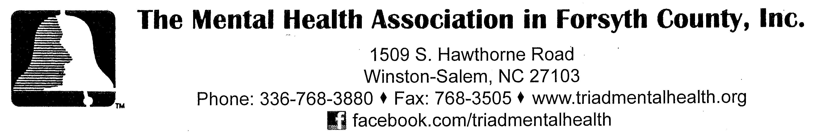 ‘RED FLAGS’ IN CHILDREN’S BEHAVIOR’

Children’s behavior is influenced by many factors including: family, friends, school, the child’s natural temperament, traumatic events, and behaviors they see modeled by others. Illness can also affect a child’s behavior and illnesses of the brain can directly affect a child’s emotions and behaviors. When a child has a behavioral or emotional problem, it is important to consider all these factors. Recent research on the brain has shown that many behaviors once thought to be “odd” or the result of “character flaws” are due to chemical imbalances in the brain. These illnesses can affect anyone, including children.

Mental health problems affect one in five children at any given time. Half of all mental illnesses begin by age 14. An estimated two-thirds of all young people with mental health needs, unfortunately, are not getting the help they need. Less than one-third of children under age 18 with a serious behavioral or emotional disorder receive any mental health services, and, often, these services are inappropriate to her/his individual needs.

Why should we concern ourselves with children’s behavior and mental health? The simple fact is that early diagnosis and treatment can improve the child’s chances of normal functioning and can help to prevent long term consequences such as: low self-esteem, poor school performance, involvement in the juvenile justice system and/or impaired social development.

Below are symptoms of children’s behavior that can aid parents, family members, teachers, school counselors, mental health professionals and community advocates/leaders that may warrant the need for mental health services. A child exhibiting a cluster of these behaviors, therefore, may indicate the need to seek professional intervention:

‘RED FLAGS’ OF BEHAVIOR IN INFANTS AND TODDLERS MAY INLCUDE:

- Too little or too much crying, excessive whining
- Sad or deadpan expression
- Little motor activity
- Lack of pleasure in developmentally appropriate activities
- Lack of social interest
- Failure to grow or thrive

‘RED FLAGS’ OF BEHAVIOR IN PRESCHOOLERS MAY INCLUDE:

- Frequent/unexplained headaches, stomachaches, and/or fatigue
- Over activity or excessive restlessness
- Frequent sadness
- Low tolerance for frustration
- Irritability
- Lack of pleasure in previously enjoyed activities

‘RED FLAGS’ IN CHILDREN’S BEHAVIOR
Page 2

‘RED FLAGS’ OF BEHAVIOR IN SCHOOL-AGE CHILDREN MAY INCLUDE:

- Frequent and unexplained headaches, stomachaches
- Significant weight gain or loss
- Feeling sad, hopeless, weepy, or empty
- Unmerited feelings of being “bad” or “stupid”
- Changes in sleeping patterns/problems with sleeping
- Unprovoked anger or aggression
- Refusal or reluctant to attend school/skipping school
- Dropping out of favorite activities
- Withdrawal, little interest in playing with others
- Running away

‘RED FLAGS’ OF BEHAVIOR IN ADOLESCENTS MAY INCLUDE

- Any of the behaviors listed above for school-age children
- Self-destructive behavior, including drug and alcohol use
- Difficulty with relationships
- Antisocial or delinquent behavior
- Inattention to appearance or grooming
- Risk taking behaviors with little thought of consequences
- Extreme sensitivity to rejection or failure
- Slowed physical responses or increased physical agitation
- Social isolation

Parents are usually the first to notice if their child has problems with emotions or behavior. In addition, observations of teachers, caregivers and other role models may lead parents to seek help for their child.

If you suspect a problem, TAKE IT SERIOUSLY, and consult with your child’s pediatrician or family doctor. You can also consult with a licensed mental health professional at these local resources:

- Partners Health Management: 1-888-235-4673
- Wake Forest Baptist Health - Child Guidance/Psychiatry: 336-716-4551
- Wake Forest Baptist Health - Brenner’s Children’s Hospital: 336-713-4500
- Insight Human Services: 336-725- 8389
- Amos Cottage Therapeutic Day Program: 336-713-7493;336-713-7444

You can consult, if applicable, with your child’s school counselor or psychologist.

The telephone number for Psychological Services with the Winston-Salem/Forsyth County School System: (336) 727-8080 or 727-8037. The telephone number of the School Social Workers with the Winston-Salem/Forsyth County School System: (336) 748-4007.

Revised November 2021

