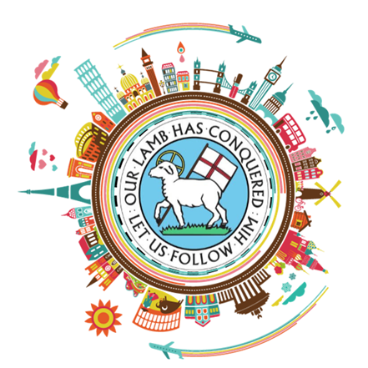
MORAVIAN YOUNG ADULT CONVO Brazen and Blazin’…Being Bohemian in 2023
July 3 – 11, 2023
A Spiritual Pilgrimage following
in the steps of the early Moravians.
The past was wide open, and the future still is...

Release of Liability Form
Every participant must sign.

By submitting this form, I allow the release of my name and personal information to all Moravian 2023 Young Adult Convo participants, and I allow the release of my name and personal information as part of an information database for Moravian Church-Northern and Southern Provinces (MCNSP)-related entities.

I agree that photos/videos shared between Moravian 2023 Young Adult Convo participants may be re-produced by Moravian 2023 Young Adult Convo. I understand that these photos/videos once shared become the property of the MCNSP and can be used for MCNSP related purposes and publicity.

In addition, I hereby freely grant to Moravian 2023 Young Adult Convo permission to publish photographs taken of me during Moravian 2023 Young Adult Convo for advertising, Internet, and internal communication purposes.

I hereby confirm that I have voluntarily chosen to participate in the Moravian 2023 Young Adult Convo planned and arranged by the MCNSP for July 3 – July 11 in Europe. I am aware that the Moravian 2023 Young Adult Convo presents risks of personal injury and property loss or damage to participants. I expressly and voluntarily assume all such risks that may result from my participation in the Moravian 2023 Young Adult Convo.

I hereby release the Moravian Church-Northern and Southern Provinces, its agents, affiliates, and successors from all liability for injury, death or other loss or damage resulting from my participation in the Moravian 2023 Young Adult Convo. I have read this agreement and release and fully understand its contents. I sign it of my own free will.

____________________________________________________ _______________________________________________
Participant Name Participant Signature

_______________________

Date

