WD News & Notes
The Newsletter of the Moravian Church,
Western District

October 2022

Rev. Bruce Nelson, President 221 E. Mills Drive, Lake Mills WI, 53551 920-253-9030 bruce@mcnp.org www.Moravian.org

Bruce’s Babblings
Brothers and Sisters in Christ:
I greet you in these early days of October. The weather has turned cooler where I live and leaves are beginning to turn colors. The season has turned to fall. Soon I will be changing out my summer clothes for my fall and winter clothes.

I was recently on a vacation in Branson, Missouri where I saw several shows, spent some time with great friends, saw some beautiful scenery, relaxed, and enjoyed being unplugged for a while. I was impressed that most of the shows were very un-political. The music and the performances were very good. The hospitality was good. It was a wonderful time.

Every time I attend a sporting event or a performance of some kind I am always analyzing what we as a church might be able to learn from others who are in the entertainment business. First of all, let me be very clear that I don’t believe that churches are in the entertainment business. But I still think we can learn things from the entertainment industry. I have written in the past about a certain baseball stadium where they made you feel like you attending their venue was the greatest thing that happened that day.
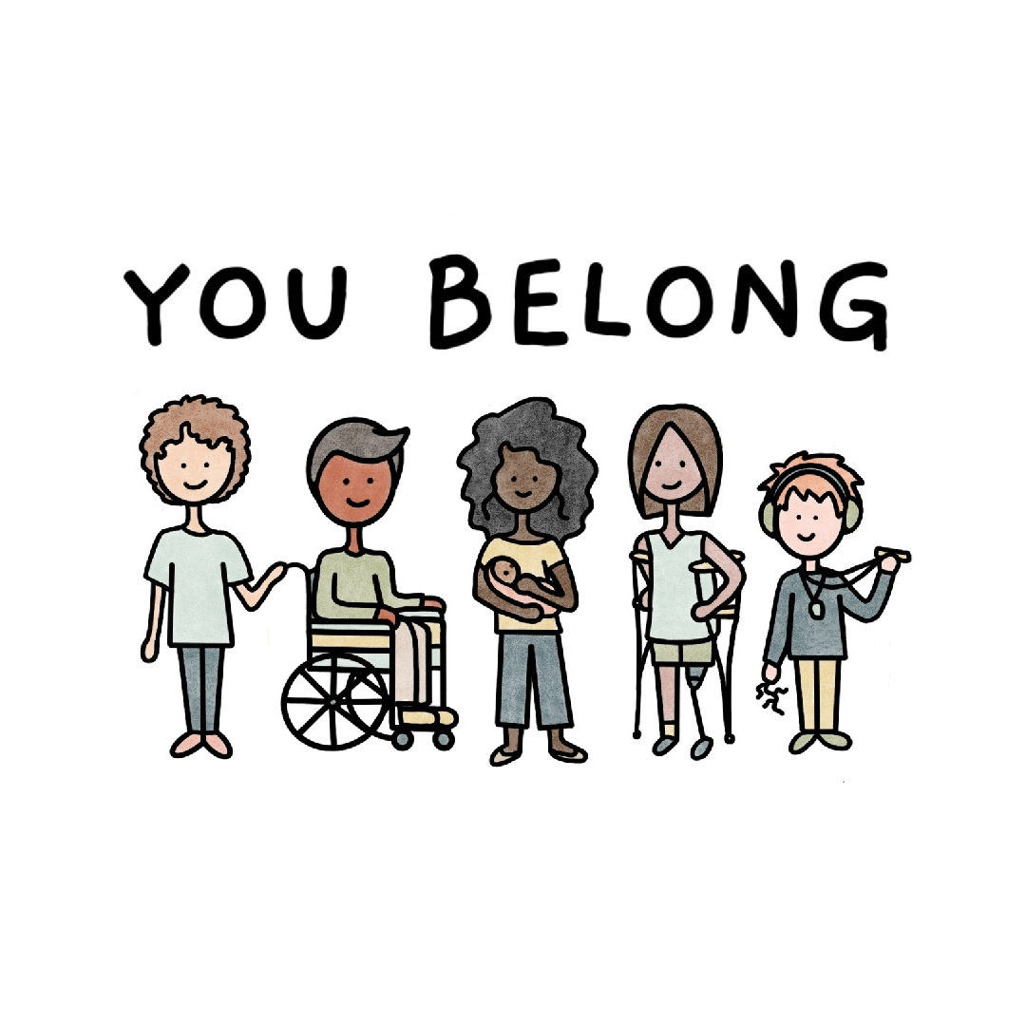
What I observed this time was just an innocent comment that was made by one of the performers. The comment was, “I have come to realize that we are more alike than we are different.” People in the entertainment industry really struggled during the worst part of the pandemic. Many of them had no steady income during that time. They are very happy to be back and performing and I think many of them no longer take for granted that people are paying hard earned money to see them. I also think that they know that we have a ways to go as a nation (and even in some of our churches) to be accepting of those who think differently than we do. In a

very small way the comment of us being more alike than we are different was a small gesture to remind us what we can be when we are at our best.

Blessings to all of you,
Rev. Bruce J. Nelson

Pastors, Save the Date
The Western District Clergy Retreat will be held at Mt. Morris from January 16-19. Pastors, we encourage you to attend this retreat. Lay members we would ask you to encourage your pastors to attend this event. More information will be coming in the future.

Pastor Christie Melby-Gibbons to Speak at an Afternoon for Mission
Please mark your calendar and plan to attend an Afternoon for Mission hosted by the Southern Wisconsin Moravians for Mission on Sunday, October 23rd at 2 p.m. at the Lake Mills Moravian Church located at 301 College Street. Pastor Christie Melby-Gibbons will speak about the wonderful and challenging things happening at the Tricklebee Cafe. Pastor Christie is blessed to be a blessing and her service in the Tricklebee Cafe and the Sherman Park neighborhood of Milwaukee is truly blessing many. There will be refreshments following Pastor Christie’s presentation so plan on staying for some fellowship time and bring a friend. All are invited.

Nonprofit Needs Home.mp4

Above is a video clip from You Belong.

Church Anniversaries
Oct. 6 London 133 years
Oct. 23 Canaan 141 years
Oct. 31 Lake Auburn 164 years
Clergy & Spouse Birthdays
Oct. 3 Carol Jones
Oct. 16 Jane Harberg
Oct. 16 Dave Sobek
Oct. 21 Jane Graf
Oct. 21 Scott Wheeler
Oct. 22 Paul Moran
Ordination Anniversary
Oct. 18 Marian Boyle Rohloff 20 years

Death
We extend our sympathy to the family of Br. Archie Roberts, a retired United Methodist Army Chaplain who served the Daggett Moravian Church in Daggett, Michigan for a time. Archie was killed in an automobile accident on September 14. He was 85 years old. Br. Archie is survived by his wife, Opal, who lives in Wallace, Michigan near Daggett, and four children. Please hold Opal and her family in your prayers at this time

Northern Province Churches in the Call Process or Without Pastors
Battle Hill, Union, New Jersey
Central (Associate Pastor), Bethlehem, PA
Covenant, York, PA
York First, York, PA
New Dorp, Staten Island NY
Tremont Terrace, Bronx, NY
Trinity, New Carrolton, MD
Our Savior’s Moravian in Altura, Minnesota
Berea Moravian Church in St. Charles, Minnesota
West Salem Moravian in West Salem, Illinois
Good Shepherd in Calgary, Alberta

Additionally: two congregations that are not in the call process but are currently without pastors are Grace Moravian in Westland, Michigan and Daggett Moravian, in Daggett, Michigan.

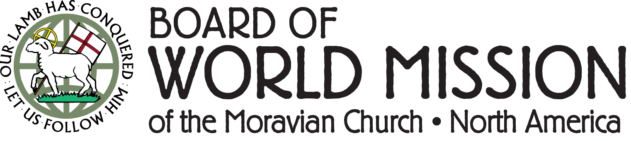
The Board of World Mission rejoices with the Moravian Church in Newfoundland & Labrador upon the commissioning of six new lay ministers. We invite your prayers for Sam Saunders, Dieter Holeiter, Sophie Ford, Sarah Jensen, Sybil Hunter, and Doris Boase (pictured below) as they step into their new ministry roles.
This was the culmination of a lay minister training program created in response to the area’s recent shortage of pastors. Rt. Rev. Chris Giesler, BWM Director of Mission Engagement; Rt. Rev. Paul Graf; and Rev. Jason Andersen led the training program via Zoom this past spring and Bishops Giesler and Graf traveled to Labrador in August for the commissioning services in Goose Bay/Happy Valley and Hopedale.
While in Goose Bay/Happy Valley, Bishops Giesler and Graf also held a special communion service and an installation service for two Chapel Servants. This was a welcomed occasion because this community had not celebrated communion for over two years due to the Covid lockdown and the fact that they did not have a pastor or lay ministers.
The commissioning of these lay ministers is a hopeful step for the Moravian Church in Newfoundland & Labrador. They also look forward to the future leadership of three candidates for ordained ministry from the area: Linda Saunders, McKinley Winters, and Darlene Winters. Please keep Sister Linda in your prayers as she recently suffered a stroke and is in the recovery process.
Board of World Mission Update Hurricane Ian's Impact on Cuba and the United States
Hurricane Ian first made landfall in western Cuba on September 27, 2022, as a category 3 hurricane with winds of 125 miles per hour. We are getting reports from our Moravian friends there of widespread power outages and flooding from wind, rain, and storm surge. Because of poor infrastructure in many areas, lack of electricity, clean water, and food is commonplace across the island.

The hurricane then made its way to the west coast of Florida, where it made landfall just south of Tampa as a category 4 storm with winds of 155 miles per hour. Damage is catastrophic and widespread across the state. By early next week, Ian will impact the southeastern coast before heading to the Carolinas. We expect heavy rains and the threat of tornadoes to continue to be a factor.

Our priority is first to allow emergency crews to do their work, and we are exploring how best to provide financial assistance to those who can quickly supply shelter, food, and water to those most at risk. We will then seek to fund mission teams and organizations that can assist with rebuilding efforts for those who will most need it for months to come.

We ask that you keep those impacted by these storms in your prayers. Pray also for those who put themselves in harm's way to keep others safe.

For further information, go to www.moravianmission.org or contact the Rt. Rev. Chris Giesler at chris@moravianmission.org.

US citizens can send checks to: Board of World Mission, 1021 Center Street, Bethlehem, PA 18018. You may also donate online at http://moravianmission.org/give/ and click on the green "Give" button at the top of the page. Please indicate that your gift is for "MDR."

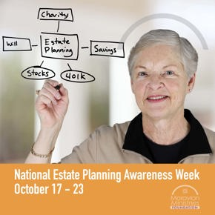
Your resource for estate planning
October 17 - 23 is National Estate Planning Awareness Week. And nobody understands the Moravian mindset about estate planning better than your Moravian Ministries Foundation in America. There is no charge to meet with us to discuss your goals. We have all the tools of philanthropy to maximize the impact of your charitable giving. Our Will Planning Wizard can help you organize your thoughts. And our free copy of Five Wishes (Use campaign code MMFA2022) can help you clearly articulate your wishes for your care.
-Vince Holbrook

Symposium Race, Slavery, and Land. Moravian Legacies in a Global Context, 1722-2000

Moravian University
November 4-5, 2022
June 2022, marked the 300th anniversary of the founding of Herrnhut by Count Nikolas von Zinzendorf, the 290th of the sending of the first two Moravian missionaries to the Danish West Indies (present U.S. Virgin Islands), and the 281st of the founding of Bethlehem on the land of the Lenape nation. More than ever before institutions, movements, and communities are facing their own histories and the role of racism and slavery therein. This calls for the rethinking and investigation of the interactions of race, slavery, and land in Moravian institutions and communities across global contexts. The symposium has leading historians, anthropologists, and political scientists from South Africa, Germany, Ireland, Jamaica, Australia, Denmark, Switzerland, and the United States discussing the legacies of racism, slavery, and land ownership in Moravian Communities global.…
Register at: https://www.moravian.edu/history/symposium

