WD News & Notes
The Newsletter of the Moravian Church,
Western District

December 2022

Rev. Bruce Nelson, President 221 E. Mills Drive, Lake Mills WI, 53551 920-253-9030 bruce@mcnp.org www.Moravian.org

Bruce’s Babblings
Brothers and Sisters in Christ:

How can it be that I am already writing an article for a December newsletter? It seemed like just a little bit ago I was attending Milwaukee Brewers baseball games or watching my granddaughter play t-ball. And yet, the calendar shows December.

There are many things about December that I really enjoy. I often can get lost in the moment during this time of year just driving around and looking at light displays. I love the music of the Advent and Christmas season. I don’t necessarily enjoy decorating our home (ask my family) but I enjoy seeing the decorations adorning our home. My mother was an excellent baker and my children make some of the cookie recipes that she used to make around Christmas time. I enjoy the goodies that come with this season.

For some people, this season is one of great expectation and hope. For others, it is a very difficult time of the year. Some look forward to a time with extended family. Others don’t have extended family to be with. Some are excited about certain traditions that they have been doing for years and years. Others are no longer able to do those traditions for whatever reason.

The past couple of Decembers and Christmases have been different because of the pandemic. This year in spite of Covid still being with us, we seem to be somewhat returning to “normal.” As I continue to get older I am beginning to wonder what “normal” really means anymore. What was normal for me when I was 20 is not the same as when I was 40. And what was normal when I was 40 is not the same as what is normal today.

As you walk these days through Advent and journey toward Christmas and all that the season offers, I encourage you to be open to what new thing the Holy Spirit may have in store for us this year. Enjoy the journey!!! Serving Christ with you,
Rev. Bruce J. Nelson

Pastors, Save the Date
The Western District Clergy Retreat will be held at Mt. Morris from January 16-19. Pastors, we encourage you to attend this retreat. Lay members we would ask you to encourage your pastors to attend this event. More information will be coming in the future.

Consecration
Brother James Heroux, pastor of the Freedom Moravian Church in Freedom, Wisconsin, will be consecrated a Presbyter in the Moravian Church on Saturday, January 14, 2023, at 3 pm CT. Brother Paul Graf will be the consecrating bishop. James was ordained a Deacon in the Moravian Church on June 16, 2018. Consecration as Presbyter is the second order of ministry in the Moravian Church.

All are invited to join James and his family in this celebration of the church and affirmation of James’ ministry. The congregation will host a meal following the service. Those unable to attend in person may join via livestream on the Freedom Moravian Church’s YouTube page. That can be found here - https://www.youtube.com/channel/UC6J4etgo6ywZdAucqtYUzew.

Please be in prayer for James, his spouse Alli, and their whole family, along with the Freedom congregation at this time of celebration.

Church Anniversaries
Dec. 4th Berea 148 years
Dec. 21st Lake Mills 166 years
Dec. 22nd Freedom 156 years

Ordination Anniversaries
Dec. 1st Amy Gohdes-Luhman 26 years
Dec. 27th Aden Ward 52 years
Dec. 27th Staci Marrese-Wheeler 30 years

Clergy & Spouse Birthdays
Dec. 6th Nan Nelson
Dec. 13th Bruce Nelson
Dec. 19th Jon Gehler
Dec. 19th James Heroux
Dec. 28th John McCarthy
Dec. 28th Rose Ullrich
Dec. 29th Lauren Schafer
Dec. 31st Greg Schafer

Prayer Concern
Please keep in your prayers Lauren Schafer, wife of Gregg Schafer, pastor of the Morongo Moravian Church in Banning, California. Lauren’s mother, Lois Barry, passed away on December 3, at the age of 91.

Northern Province Churches in the Call Process or Without Pastors
Battle Hill, Union, New Jersey
Central (Associate Pastor), Bethlehem, PA
Covenant, York, PA
York First, York, PA
New Dorp, Staten Island NY
Tremont Terrace, Bronx, NY
Trinity, New Carrolton, MD
Our Savior’s Moravian in Altura, Minnesota
Berea Moravian Church in St. Charles, Minnesota
West Salem Moravian in West Salem, Illinois
Good Shepherd in Calgary, Alberta

Additionally: two congregations that are not in the call process but are currently without pastors are Grace Moravian in Westland, Michigan and Daggett Moravian, in Daggett, Michigan.
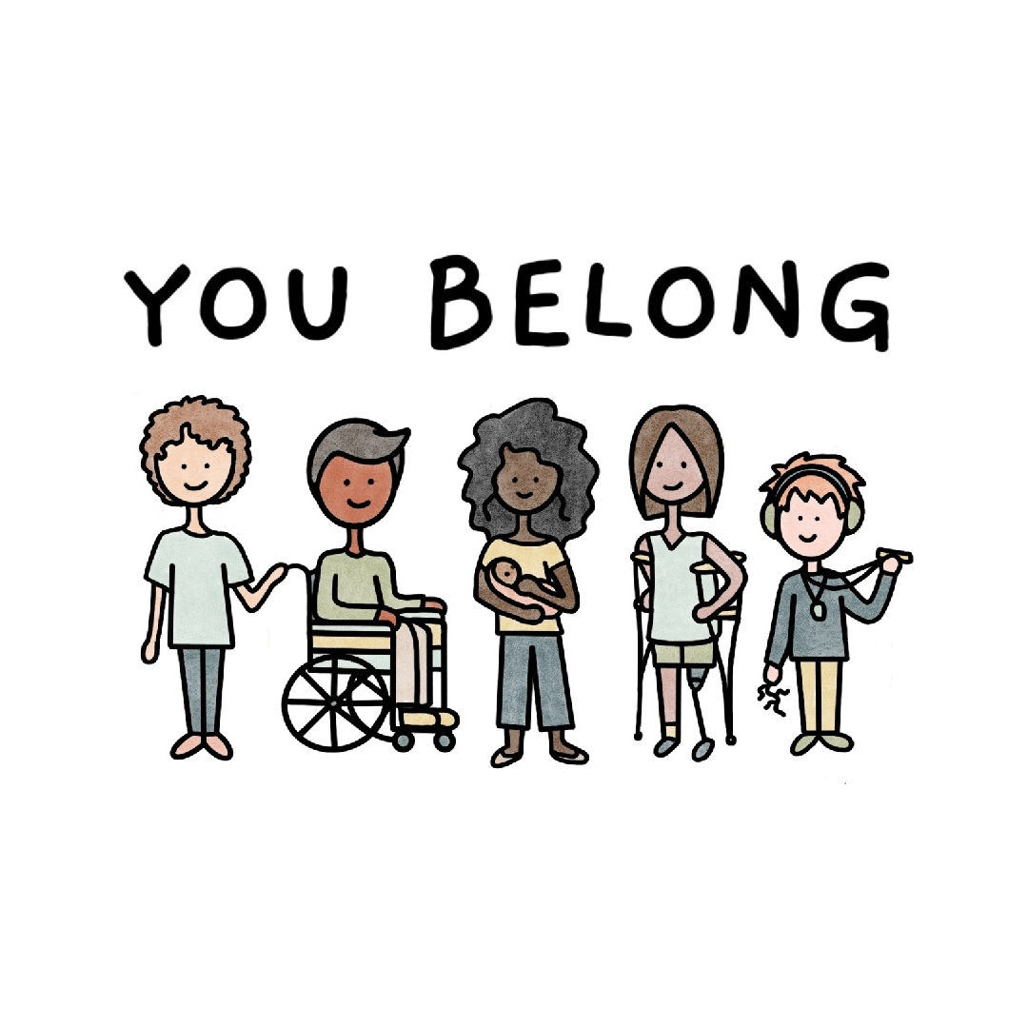

You Belong is about to enter our 18 months as an organization. Our faith community continues to grow and nourish many while our programs consistently see new faces each month. We also have some BIG news to share! We are moving into a new space that we will call home for the next three years! Our new home is a 6,000 square foot facility located at 2960 Allied Street, in the southwest corner of Green Bay.

If that weren’t enough, You Belong is about to bring to life a new non-profit. The center will be a 501(c) non-profit that will exist parallel to the faith community. The Center will become that home for several of our programs as well as The Adventure Zone. The Adventure Zone will be a physically and programmatically designed children’s learning and play center filled with exhibits and other learning adventures for children newborn-10 years old. Needless to say, our team is busy, excited, and filled with hope for the journey ahead. –Greg Behrend

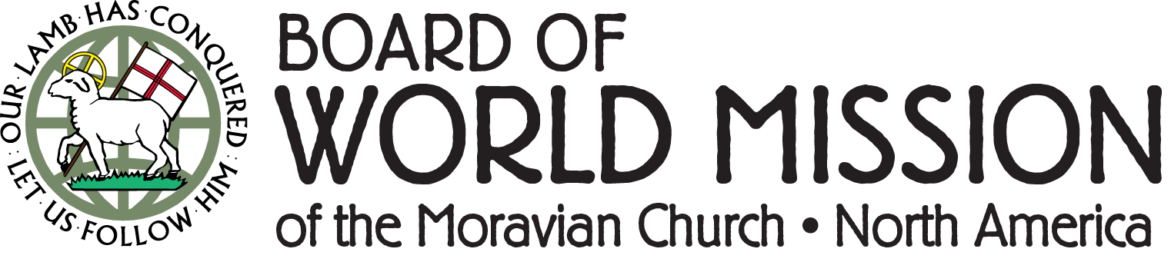
The Board of World Mission Announces New Education Fund
Universal education has been a Moravian core value since the founding of the Church in 1457. As 2022 comes to a close, the BWM is pleased to announce the launch of our Education Fund, which will continue to grow and be a source of funding for Moravian education ministries for years to come. We invite you to be part of this effort by including the Board of World Mission in your end-of-year giving.
To give you an idea of the blessing your gift will be to a Moravian educator or student, here are some impact examples based on our current projects:
● $25 = one week of schooling for a student in Kyiv, Ukraine
● $75 = one month of instructor certification training for a teacher in Ngiehun, Sierra Leone
● $150 = one week of speech therapy for all students at Star Mountain Rehabilitation Center in Ramallah, Palestine
● $2,000 = an international BWM conference for one church leader
● $5,000 = one year of training for a future doctor, nurse, or medical support staff at the Moravian clinic in Ahuas, Honduras
Go to MoravianMission.org/Education to learn more. To contribute, please donate online at MoravianMission.org/Give or mail checks to: Board of World Mission, 1021 Center St. Bethlehem, PA 18018. Please indicate that your gift is for “Education Projects.”
We also invite you to follow along with our 2022 Advent calendar, which encourages Moravians to count their blessings and to be a blessing to others. Learn more at MoravianMission.org/Advent and join in at any point during Advent by contacting sylvie@moravianmission.org.
IBOC December Highlights
- Brian Dixon’s latest release, Losing Light–Walking by Faith but Wanting to See is now available at the IBOC store. Losing Light is part lament, part study and discussion, and a porchlight left on welcoming you home. 116 pages. $12.95.
- Inspire friends and family with our latest book offering: Your Friendly Neighborhood Hope Shop by Rev. Mandy Mastros offers Advent meditations and shares hope through the stories of people living on the streets of Lancaster PA. $10.95.
- Help fill time during the winter season with a 500-piece PUZZLE - a Moravian Star Mosaic. This will bring hours of fun. $30.00
- Moravian Seal Ornaments handmade of folded fabric is a wonderful gift for pastors, musicians, family, and friends. 3”. $20.
- Moravian Star Café Mug are a dark red/brick color and holds 18 oz. of your favorite beverage. These are dishwasher and microwavable safe. 6”. $11.95.
- What Good News the Angels Bring is the latest Christmas music offering from the Moravian Music Foundation and the Bach Festival Society of Winter Park, Florida. 22 tracks. $16.

For these and other great products, visit our store at store.moravian.org or call Jill at 610-867-0593 ext. 703.

Crossroads 2023 Winter and Spring Courses
Note: All Courses are in person for those who are able AND also real time on Zoom.

Your choices:
-Ministry Journeys of the New Testament with Rev. Dr. Joanne Marchetto, Mondays, Jan. 9 – Feb. 27, 6-9 p.;
-Mapping the Route - Conversations in Theology with Rev. Dr. Bill Falla, Thursdays, Jan. 5 – Feb. 23, 6-9 p.m.
-Traveling Mercies Congregational Care with Greg Krausz and Diane Kareha, Mondays March 6 - May 1 (except April 3), 6-9 p.m.
-Traditions - Exploring Denominations & Religions with Rev. Dr. Bill Falla, Thursdays March 9 – May 4 (except April 6), 6-9 p.m.

For more information, Contact Jill Peters at petersj2@moravian.edu or go on the website at www.moravianseminary.edu/crossroads.

Three Resolutions You Can Keep
The first step in reaching a goal is to have one. Sadly, fewer than 1 in 3 Americans even made a New Year’s Resolution last year, according to ABC News. Of those who did, the second-most common theme was to improve finances. (Improving health/losing weight took the top spot). And, according to Forbes, 80% of those who do make resolutions abandoned them by early February.
We can’t help you stay on a diet, but your Moravian Ministries Foundation in America (MMFA) is here to help you beat the odds with three resolutions you can keep in 2023. Use the marvels of technology and structured programs to keep your financial resolutions in 2023.

Resolution 1: Improve finances
Sign up for our next FreedUp class by January 9. MMFA pays the fee and provides the materials for Moravians. The virtual classes occur on six consecutive Thursdays at noon or 7:00 p.m. beginning January 19. MMFA’s own Laura Watson leads the virtual class, which has received rave reviews from Moravians you may know. Click here to read more!

Resolution 2: Document your plan
Did you know 68% of Americans lack a valid will? Make a resolution to be among the minority of people who do. Create your will, medical power of attorney, advanced directive, and other important legal documents.
MMFA is proud to introduce our new Legacy PlannerTM online legal document system. It’s an end-to-end way to create important documents to remember the people and ministries you love. It produces the actual documents and provides instructions to get them witnessed, notarized, and filed in the state where you live. Again, this service is free to anyone who is remembering any Moravian ministry in their plans.

Resolution 3: Fulfill your pledge
You’ve told your congregation, fellowship, or worship community your plans to financially support them during 2023. So, what’s better than your pledge card? A recurring gift on the Moravian Giving Portal. Surprisingly, nearly 1 in 4 people who do not keep their resolutions report the reason is that they forgot. The Moravian Giving Portal can help you remember by scheduling regular offerings on a monthly basis. It’s easy to do. And MMFA pays any card processing fees. The portal remembers even if you forget. Of course, you can change or discontinue your recurring gift at any time.
-Vince Holbrook

