WD News & Notes
The Newsletter of the Moravian Church,
Western District

April 2023

Rev. Bruce Nelson, President 221 E. Mills Drive, Lake Mills WI, 53551 920-253-9030 bruce@mcnp.org www.Moravian.org

Bruce’s Babblings
Greetings Brothers and Sister in Christ:

As I write this, it is an overcast and dreary day. I am writing this before Holy Week but my hunch is that you will be reading this during Holy Week. As I reflect on the weather it is dreary, sort of rainy, a storm may be coming later in the day, and significant rain is forecast with snow north of where I am.

I believe I have had enough snow (actually too much snow) for my liking this season. I would be happy to not see snow again until November or December of this year. However, it is not up to me to determine whether or not it will snow again. I don’t know if it is going to snow this season again or not. I don’t know if we are done with snow or if I have to shovel more before the grass is ready to be mowed. What I do know is that warmer weather is on the way.

Just like the dreary overcast day that I am experiencing as I write this, we will go through the heart-wrenching difficult days of Holy Week. I find it to be not easy sometimes to re-read the pain and agony that our Lord went through on our behalf as we relive the events of Holy Week. But Easter is coming! We will gather together perhaps in the early morning hours and we will say to one another, “He is risen indeed!” Just as Easter Sunday is coming, so are the warm sunny days of late spring and summer. I am not trying to wish away the days of early spring, but I am looking forward to warmer and sunnier days! In the same way Easter Sunday is coming.

We will have to journey through Holy Week before we get to Easter just as we will have some dreary days before we have warm and sunny days.

Hopefully journeying with you,
Rev. Bruce J. Nelson

Northern Province Churches in the Call Process or Without Pastors
Battle Hill, Union, New Jersey
Central (Associate Pastor), Bethlehem, PA
New Dorp, Staten Island NY
Tremont Terrace, Bronx, NY
Trinity, New Carrolton, MD
Our Savior’s Moravian in Altura, Minnesota
Berea Moravian Church in St. Charles, Minnesota
Good Shepherd in Calgary, Alberta

Additionally, these congregations are not in the call process but are currently without pastors: Grace Moravian in Westland, Michigan, Daggett Moravian, in Daggett, Michigan, Edmonton Moravian and Heimtal Church both in Edmonton, Alberta.

Camp Dates for 2023

Chetek: July 16-22 (Mt. Morris)
Tar Hollow: July 16-22
Winmor: July 23-29 (Mt. Morris)
Illiana: July 24 - 28
Junior: July 30-August 3
Camp Bethany (Michigan and Ohio 2nd grade through 6th grade): July 31 - August 4

Church Anniversaries
April 3 Sister Bay 127 years
April 7 Glenwood 94 years
April 9 Veedum 105 years
April 13 Christian Faith 138 years
April 21 Our Savior’s 47 years

Clergy & Spouse Birthdays
April 1 Mary Lou Plummer
April 1 Barbara Rich
April 8 Kathy Sherwood
April 13 Nancy Von Boeckmann
April 17 Kay Ward
April 21 Charlie Ganz
April 24 Barb Berg
April 27 Al Bergmann

Installation
Jon Michael Deisher was installed as the licensed lay pastor at West Salem Moravian Church on April 2.

Friends of Mt. Morris Camp & Retreat Center!
We wanted to make you aware of these upcoming events at Mt. Morris Camp.
#1. Our Men's Retreat is coming up May 5-7. Rev Kurt Leibenow will be leading our discussions and worship surrounding our theme - "reNOVAtion". We will be discussing all the ways Jesus is changing and molding us to think and act in a new way. This is a great weekend for all guys (21 and older) to relax, laugh, and have a great weekend together. For more info and to register, click HERE:
#2. Our Family Fun Weekend is June 2-4. We will celebrate the arrival of summer while enjoying a ton of great outdoor activities like swimming, creek walking, games, and relaxing! Rev. Jason Anderson will be leading our devotions and worship. Join us for great food (s'mores), great friends and great times! For more info and to register online, click HERE:

#3. Service Camp is May 17 – 23. Cost: None
Come help prepare the camp grounds for the summer youth camps. Come as many days as you are able. All ages and abilities are welcome.
We look forward to seeing you here at camp!
Dan Scharnhorst
Camp Director

During Lent and Easter we celebrate the sufferings, dying, death and resurrection of our Lord, Jesus Christ. As Jesus was raised in triumphal rebirth, so our baptism marks our spiritual rebirth into “new creatures”, saved by the Messiah’s blood. A reflection of this divine spiritual miracle is seen each Spring as we witness the natural rebirth of flowers, trees and gardens. We find new reasons to hope for a physical renewal that mirrors the spiritual renewal brought about by Jesus’ sacrifice.
In Central America, our Sisters and Brothers are experiencing a similar sense of hope and physical renewal. Last year, many families lost virtually all of their crops to floods. Rains and floods are increasingly unpredictable. In 2022, during the dry season months of February and March, unseasonable rains destroyed the bean crop. In May it was impossible to plant rice due to continued rains. Perennial crops such as cassava and
bananas, along with fruit trees, were lost.
The Board of World Mission’s Moravian Disaster Response program has sent medicines and food to help with recovery. A major effort has been to supply bean and vegetable seeds as families look with hope toward a bean harvest in March or April and a rice harvest in September. As they anticipate more than just the one daily meal that has characterized their existence for many months, there is hope for the future. As our Easter worship celebrates the spiritual rebirth that comes with Christ’s resurrection, we hope for physical rebirth with the planting of bean, rice and vegetable seeds in Central America.
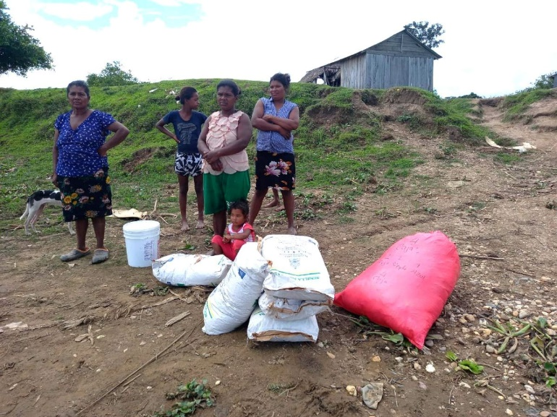

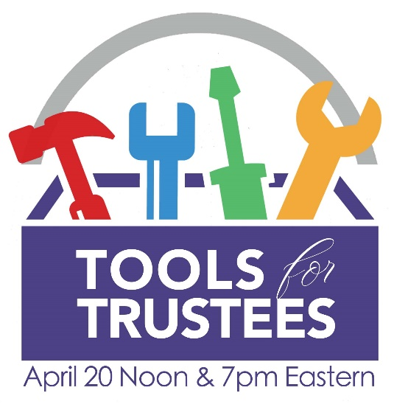
Tools for Trustees, register by April 17
By Vince Holbrook
If you're serving on the Joint Board of a Moravian congregation, or are a past, present, or future Trustee, this one-hour online session is for you! Tools for Trustees is an introduction to the resources available to congregations through the Moravian Ministries Foundation in America. You'll learn how we can help you:
- Develop and support stewardship
- Facilitate giving
- Optimize planned giving
- Manage investments
- Apply for grant funding for ministry
There are two opportunities to join a one-hour session on April 20. At noon or at 7 p.m. Eastern Daylight Time. (Both sessions are the same, so you only need to register for one).
Click below to register by April 17 for a session on April 20!
12 noon EDT on April 20

7 p.m. EDT on April 20

300 Years of Herrnhut, Christian Gregor, and Beyond
A concert featuring the Unitas Chorale, a performing ensemble of MMF, in a program celebrating the 300th Anniversary of the Herrnhut Congregation in Germany, birthplace of the Renewed Moravian Church. Music selected will celebrate Herrnhut (founded 1722) and Christian Gregor (born 1723), known as the father of Moravian music. The Chorale is directed by Gwyneth Michel and accompanied by Luke DiGiacinto. Sunday, May 7, 2023, 4:00pm; Advent Moravian Church, 3730 Jacksonville Rd., Bethlehem, PA. moravianmusic.org/unitas-chorale-concert-3/
Reception to follow. No ticket required; free-will offering.
May 7 is also Moravian Music Sunday, a project of the Moravian Music Foundation. Resources, materials, and music made available online.

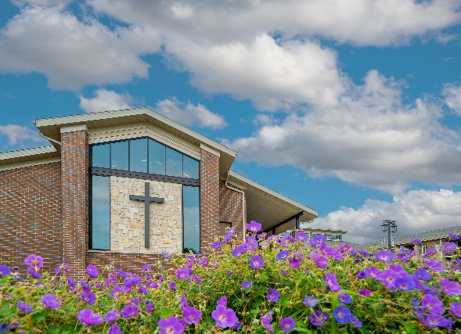

Dedication Service of The Grove
You are invited to the Dedication Service of the Grove! Join us as we celebrate our new chapel and multi-purpose space on The Marquardt campus.

Saturday, April 22 at 2 p.m.
The Grove
1045 Hill Street
Watertown, Wisconsin

Refreshments and fellowship to follow the service.

