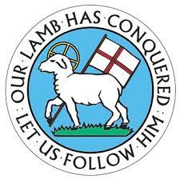
Tell Me About Synod
Part I

What is a District Synod?

A District Synod is a gathering of representatives from Moravian congregations belonging to a District (a subdivision) within a Province of the Moravian Church. Its purpose is to confirm, renew, and establish bonds of Christian love and fellowship both among individual members and between congregations and to stimulate and strengthen ministry undertaken together.

Significantly, in the Moravian Church the majority of those in attendance at synods are lay persons, rather than clergy. Such representation is reflective of the church’s conviction that sharing the good news of Jesus Christ is the calling of the entire church, rather than a task restricted to those called to ordained ministry.

By Rev. Derek French

