The Fresh Expressions Journey

- Listen to God and the people you are called to serve.
- Find a way to love and serve the people round you.
- Build community with those you serve.
- Offer opportunities for individuals to explore becoming disciples of Jesus.
- Let a Christian community, a congregation or church, take shape.
- Encourage new believers to do it again by leading others on a similar journey.

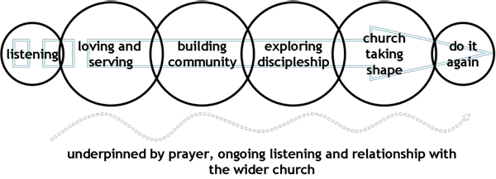
Ask another Christian. God wants us to work in teams. That's why Jesus sent out his disciples in pairs (Luke 10. 1). So if you want to a start a fresh expression of church, prayerfully find someone to do it with.
Begin with what you've got - who you are, what you know, who you know and what you have: what are your passions and interests - cooking, art etc.? What do you know about - mending bikes? Who could you share your passion with - who could you ask to help? For example, say you go cycling with friends. Could you ask two the three other Christians to organize food for the cyclists when you get back? Then you’ll be able to share your lives more deeply together. What do you possess - a home to meet in, a car to transport people, support group first met. And don’t forget: other people can serve you!

Chat to others - to God directly in prayer, to those you are seeking to serve and to others with wisdom to share. Listen and learn all you can.
For example, freshexpressions.org.uk/stories contains over 200 stories of fresh expressions, often with contact details. Why not email someone doing the type of thing you have in mind? Don’t short change this listening! If you really want to serve people experiment like mad! Don’t be shy about trying something to see round you, use conversations with them to propel you forward.
Dream up lots of possibilities. Keep asking ‘what if…?’ ‘What if we did this?’ ‘What if we did that?’ Then ask, ‘Why not?’ ‘What if…?’ leads to ‘why not?’ which takes you to another ‘what if…?’ Eventually, through prayer, you will come up with a brainwave! Expert designers keep exploring possibilities. Inexperienced ones miss out on creative ideas because they narrow down options too early.
Experiment like mad! Don’t be shy about trying something to see if it works. Messy Church started as a six-month experiment, which the leaders adapted as they went along.
Follow the fresh expressions journey (above)
God’s role is vital! So pray as you follow the ABC.

