WD News & Notes
The Newsletter of the Moravian Church,
Western District

July 2021

Rev. Bruce Nelson, President 221 E. Mills Drive, Lake Mills WI, 53551 920-253-9030 bruce@mcnp.org www.Moravian.org

Bruce’s Babblings

Brothers and Sisters in Christ:

I find it hard to believe that we are in the month of July. Many things take place in the month of July. In the Western District many of our church camps that are having camp this year take place in July, although Mindyy took place the latter part of June. July is also a month when lots of vacations take place. This is especially the case after many of us were unable to take vacations last year at this time. Still another event that may take place in July is family reunions. I am certain that I am missing many events that potentially take place this month.

However, perhaps one of the biggest events during the month of July is the celebration of Independence Day. We celebrate Independence Day annually on July 4th. This is a day to celebrate our independence as a nation. But as Christians we are not independent. Rather, I would contend that we must be dependent. We must be dependent upon others. I am dependent upon others, I rely upon others to partner with me to do ministry. I am dependent upon others to do things that they do well that I don’t do so well. I am dependent upon others for friendship and fellowship.

I Corinthians 12 speaks of the body of Christ and of how we need all parts of the body for it to function effectively.

I look forward to celebrating Independence Day with my family soon. But as I celebrate our independence as a nation, I realize how dependent I am on others as they help me, challenge me, affirm me, and help me to be the best version of me that I can be. I hope that you too have people that you can depend on.
.
Serving Christ with you,
Rev. Bruce J. Nelson

2021 Summer Camps
Chetek is for youth completing 9th grade – age 21.
July 18th – 24th
Winmor is for youth finishing 6th grade – 8th.
July 25th-31st
Junior Camp for campers completing 2nd grade – 5th. August 1st-5th.

All registration information is on wdcamping.com web site.

Mt. Morris Update
I am writing to give you a very quick update on the new building project at Mt. Morris Camp. As you’ve probably heard, we had a generous group of supporters offer $75,000 in matching funds to help restart our fundraising efforts. Since we began the matching program, we have received 65% of the $75,000 goal! Thank you for all your kind and generous support.

The original deadline for the matching funds was June 30. We still hope to reach the $75,000 goal so we are extending the deadline until August 15.

We are working with the building designer on some final details. Once that is complete, we will be able to announce when the groundbreaking and construction will begin.

Thank you very much for your prayers, generosity and patience as the project has been moving along. We are thankful to all of our supporters and know that without you, we cannot exist.
God’s Blessings!
Dan Scharnhorst
Executive Director

Grant for Lay Ministry
The Western District has received a generous bequest from the family of Rt. Rev. Wil and Ruth Behrend. With some of this gift, your Western District Board has developed the Behrend Memorial Grant for Lay Ministry. We are encouraging churches to write requesting a grant for $1,000 per congregation for use with an ongoing or a new lay-led ministry.
This grant is open to any congregation or emerging ministry in the Western District and the grant money will be distributed after the local congregation or emerging ministry has filled out the grant application and any other requested materials. Grant application forms have been sent to all congregations and emerging ministries in the Western District. Completed application forms should be sent directly to District President Bruce Nelson either via email (bruce@mcnp.org) or via snail mail at: Rev. Bruce J. Nelson, 221 East Mills Drive, Lake Mills WI, 53551.

Clergy & Spouse Birthdays
July 1 Janet Wetzel
July 9 Paul Graf
July 12 Valeria Johnston
July 12 Amy Behrend
July 16 Thomas Luhman
July 22 Beth Rohn-Habhegger
July 28 Dawn Volpe
July 31 Judy Ganz

Ordination Anniversaries
July 3 James Johnston (55 years)
July 13 Harvey Prochnau (52 years)
July 16 Beth Rohn-Habhegger (20 years)
July 17 Mike Eder (10 years)
July 21 Dawn Volpe (36 years)
July 21 Andy Kilps (14 years)
July 30 Bob Smith (60 years)

The Call Process
Please hold the West Salem Moravian, Our Savior’s Moravian and the Unionville Moravian congregations in your prayers as they continue in the call process.

Please remember in prayer Br. Charlie McDonald and the Chaska Moravian Church as Charlie is installed as pastor on July 18th.

The District Board continues to be grateful for the leadership of the Joint Board at Grace Moravian as they continue to lead their congregation.

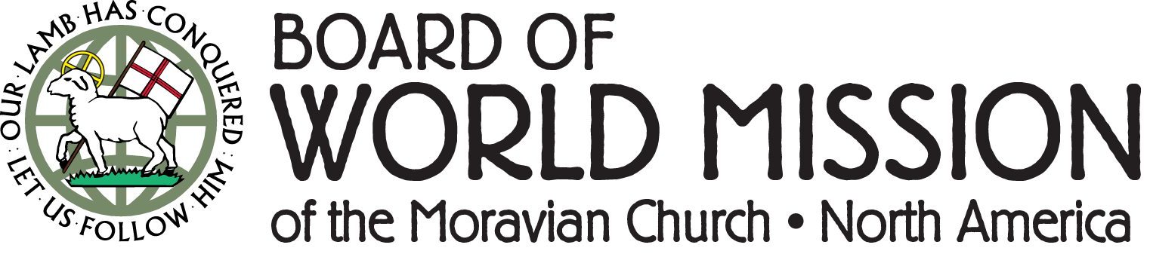

Did you know……. BWM staff have once again started to travel!!! With the wider availability of a vaccine, and loosening travel restrictions in some parts of the world, BWM staff members are getting on the move!
Executive Director, Justin Rabbach, was able to attend the recent Synods of both the Honduras Unity Province and Mission Province in person. This opportunity to renew contacts and discuss topics such as the ongoing theological education and medical work supported by the BWM with leaders was invaluable.
If your congregation would like a BWM staff member to offer a mission moment, lead a program, workshop or worship service, virtually or in-person, please be in touch! We would love to start receiving invitations to come share about mission and will work with you to abide by all local health and safety guidelines in place!

Western District Women’s Retreat
The Lake Mills Moravian Women are planning their Western District Women’s Retreat at Mt. Morris to be held September 17-19. Rev. Christie Melby-Gibbons will be the guest speaker as we enjoy a weekend of fellowship.

Christie will focus on what it means to be restricted and what it means to be free/restful, and if there is such a thing as a good restriction.

We hope you can join us at tranquil Mt. Morris to take time to relax and enjoy the Lord’s creation. In addition to a great program there will also be time for fellowship, laughter, sharing and delicious meals. The cost will be $140 for housing in Black Oak or $110 for housing in one of the cabins. Friday dinner through Sunday breakfast meals are included. If you are only able to come for part of the weekend, that could be accommodated as well. Registration materials are available through your church office.

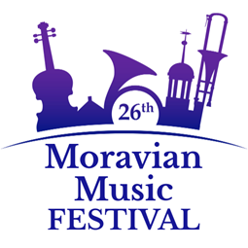

Presenting the Glenwood Moravian Community Church Trombone Choir

Join us for “Popcorn in the Pews.”
A free virtual premier concert featuring Moravian Brass ensembles from around the world.
July 22, 2021 at 6 p.m.
725 Gilmore St., Madison, WI
~
The 26th Moravian Music Festival, Part I (online), is coming up in 2 weeks! Registrants will have access to many videos and resources for musicians, directors, and listeners, with topics ranging from copyright to choir directing, instrument repair to Moravian music history. Whether or not you are registered, please join in with Moravians around the world to “attend” online concerts each night of Festival week, beginning Sunday, July 18 through Friday, July 23. Concert preludes and devotions will begin at 7:00. The 26th Moravian Music Festival, Part II (in person), will take place July 26-30, 2022, in Bethlehem, Pennsylvania. Please visit www.MoravianMusicFestival.org for concerts schedule, registration information, and pictures from past Festivals!

Giving Portal transaction fees are on us
The Moravian Ministries Foundation in America will begin paying the processing fees for online gifts made through the Moravian Giving Portal, beginning July 1. The Foundation itself has never charged any kind of fee. But, the backend processor, Blackbaud Merchant Services, charges a financial, processing fee similar to others who perform this service. This fee has been deducted from the gift, so the receiving congregation or agency got the net balance of the gift after the fee.

While Blackbaud Merchant Services continues to charge the fee, MMFA will pay it beginning July1. The receiving congregations, agencies, and ministries will now receive the full amount of the donor’s gift.

“Many congregations and agencies may now find the fee-free online giving service provided and maintained by MMFA more attractive than their own third party provider. This removes the last roadblock for online gifts through our portal and we are extremely thankful to our donors and investors who make this possible,” said MMFA president and CEO Chris Spaugh.

Given that fees still get charged, we encourage donors to consider direct debits (of a checking or savings account) vs. credit card transactions whenever possible. MMFA only absorbs a 75-cent fee for direct debits while card transactions are 2.79% of the donation amount.

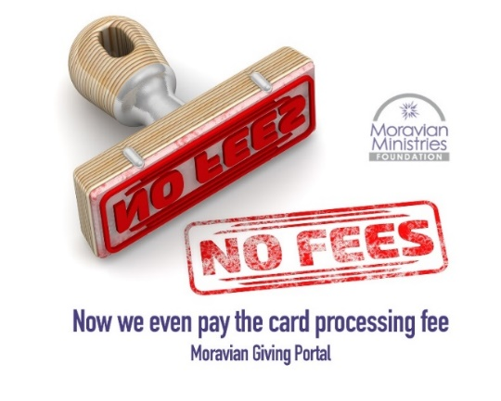

Concurrent with its decision to cover the transaction fees, MMFA will also make some other changes to Giving Portal service to the Moravian Church in America:

- MMFA will provide reports and payments to the recipients on a monthly basis, the Foundation was doing this twice monthly, during the past year.

- MMFA will establish accounts for all the Moravian agencies, including those who have their own pre-existing online giving tools on their websites. During its first two years, the Giving Portal simply redirected visitors from the Portal to the agency’s page to make the gift there. Maintaining the redirection links has been challenging, so MMFA will now enable all gifts directly through the Portal (as it has been doing for the congregations).

