**WD News & Notes**

The Newsletter of the Moravian Church,

Western District

**August 2021**

Rev. Bruce Nelson, President • 221 E. Mills Drive, Lake Mills WI, 53551 • 920-253-9030 • bruce@mcnp.org • www.Moravian.org

Bruce’s Babblings

Brothers and Sisters in Christ:

As you read this, we will be into the last functional month of summer. I realize that officially summer doesn’t end until September 22 but basically summer is done when schools are back in session and for most students that will be no later than the day after Labor Day. I hope you have found ways to enjoy the months of June and July.

As we turn the page to August, I am reminded of the events of August 13, 1727 in Berthelsdorf. I believe many of us know the story. This date is often called the spiritual birthday or the Pentecost of the Moravian Church. After some serious disagreements, struggles, even disharmony among the settlers on Count Zinzendorf’s estate, there was an outpouring of the Holy Spirit. We are told that the people who were having trouble getting along with one another, suddenly were so filled with love for one another that they did not want the worship service to end. They decided to hang around and share a meal together.

As I reflect on these events, I can’t help but see similarities to what we are experiencing today. We are in the midst of difficult times. Our Mid-States church campers instead of gathering for a week of camp, instead gathered for bit by bit in Ohio for a day. Our Western Region camps did take place but there were precautions in place to keep campers as safe as possible. Numbers were down but the camps still went on. There, no doubt, were some challenges to doing camp in a new way but I have been told by camp leaders that the Holy Spirit still showed up at camp. Churches are struggling to be safe and also to meet the spiritual needs of all of their members.

What happened following August 13, 1727 is more remarkable than the event itself! It was after August 13 that several sets of missionaries went out to share the Gospel with others around the world. Could we have another August 13 Moravian Pentecost? Could we have another event when the Holy Spirit visits us in a profound way? I don’t claim to be a prophet but I see no reason why that cannot happen. I would encourage us to be praying for that. But at the same time I would encourage us to be open to where the Holy Spirit may be nudging you.

I have been traveling quite a bit once again and it is good to see people in person. I am fully vaccinated but also a bit concerned about increasing covid numbers. I hope to see many of you in my travels and to hear how the Holy Spirit has touched you and/or your church family.

Serving Christ with you,

*Rev. Bruce J. Nelson*

Western District Women’s Retreat

The Lake Mills Moravian Women are planning their Western District Women’s Retreat at Mt. Morris to be held September 17-19. Rev. Christie Melby-Gibbons will be the guest speaker as we enjoy a weekend of fellowship.

Christie will focus on what it means to be restricted and what it means to be free/restful, and if there is such a thing as a good restriction.

We hope you can join us at tranquil Mt. Morris to take time to relax and enjoy the Lord’s creation. In addition to a great program there will also be time for fellowship, laughter, sharing and delicious meals. The cost will be $140 for housing in Black Oak or $110 for housing in one of the cabins. Friday dinner through Sunday breakfast meals are included. If you are only able to come for part of the weekend, that could be accommodated as well. Registration materials are available through your church office.

Grant for Lay Ministry

The Western District has received a generous bequest from the family of Rt. Rev. Wil and Ruth Behrend. With some of this gift, your Western District Board has developed the **Behrend Memorial Grant for Lay Ministry**. We are encouraging churches to write requesting a grant for $1,000 per congregation for use with an ongoing or a new **lay-led** ministry.

This grant is open to any congregation or emerging ministry in the Western District and the grant money will be distributed after the local congregation or emerging ministry has filled out the grant application and any other requested materials. Grant application forms have been sent to all congregations and emerging ministries in the Western District. Completed application forms should be sent directly to District President Bruce Nelson either via email ([bruce@mcnp.org](mailto:bruce@mcnp.org)) or via snail mail at: Rev. Bruce J. Nelson, 221 East Mills Drive, Lake Mills WI, 53551.

Clergy & Spouse Birthdays

Aug. 4 Barry Lehman

Aug. 5 Susan Weinlick

Aug. 5 Charlie McDonald

Aug. 6 Christopher Samsen

Aug. 11 Mary Bielke

Aug. 14 Joy Hicks

Aug. 14 Tom Von Boeckmann

Aug. 17 Marcia Eder

Aug. 19 Val Lehman

Aug. 21 Karen Kilps

Aug. 24 Aden Ward

Aug. 25 Sharon Lauderman

Aug. 26 Sam Propsom

Aug. 30 Amy Straughan

Ordination Anniversaries

Aug. 7 Jennifer Moran (10 years)

Aug. 20 Katie Van Der Linden (15 years)

Aug. 26 Kay Ward (42 years)

Aug. 24 Judy Ganz (13 years)

Aug. 28 Nancy Von Boeckmann (28 years)

Aug. 29 Reid Lauderman (11 years)

The Call Process

Please hold the **West Salem Moravian, Our Savior’s Moravian and the Unionville Moravian** congregations inyour prayers as they continue in the call process.

The District Board continues to be grateful for the leadership of the Joint Board at **Grace Moravian** as they continue to lead their congregation.

Prayer Concerns

Br. Joel Russell, pastor of the Bethel and Goshen Moravian Churches in rural North Dakota, continues his recovery from a jeep accident last month. Joel remains in a Fargo hospital with a broken sternum and ribs. He is making slow, but steady progress on a long road toward healing. Please pray for Joel, his wife Jan, and their family as they walk day by day on this journey.

We offer sympathy and prayers to Sr. Holley Weavil, wife of Br. Terry Weavil, retired pastor living in Illinois. Holley’s mother, Betty Stewart passed into the arms of our Lord on Saturday, July 3 at a hospital in Bethlehem, PA. There will be a celebration of life sometime in October. Please remember Terry, Holley, Holley’s brother Bob Stewart, and their entire family in your prayers at this time of grief.

We remember in prayer Sr. Peg Smith, wife of Br. Bob Smith, retired pastor living in Nooksack, Washington as she deals with a flare-up of pulmonary fibrosis and as they make decisions for further care.

Update from Mt. Morris

Greetings Western District Congregations!

We are currently hosting our Junior Camp and it's going great! It's been fantastic to have all of the Moravians camps back this summer. We are excited about all that God has been doing at this holy place!

One quick update for you regarding our Multi-Purpose Building that we are getting ready to build. As you may have heard, several generous donors have offered a $75,000 gift toward the building fund to be used as a matching grant. We are excited to let you know that we have only $7,800 to go to meet the goal and match the $75,000. We have until August 15 to do it and we are asking you to help us spread the word.

Donations can be mailed to the camp or given at our website donation portal- go to Mt-Morris.org and click on the Donate tab.

We know that this goal can be met if we are able to spread the word, please share as you are able with your congregations and community.

Thank you very much!!

*-Dan Scharnhorst*

\\\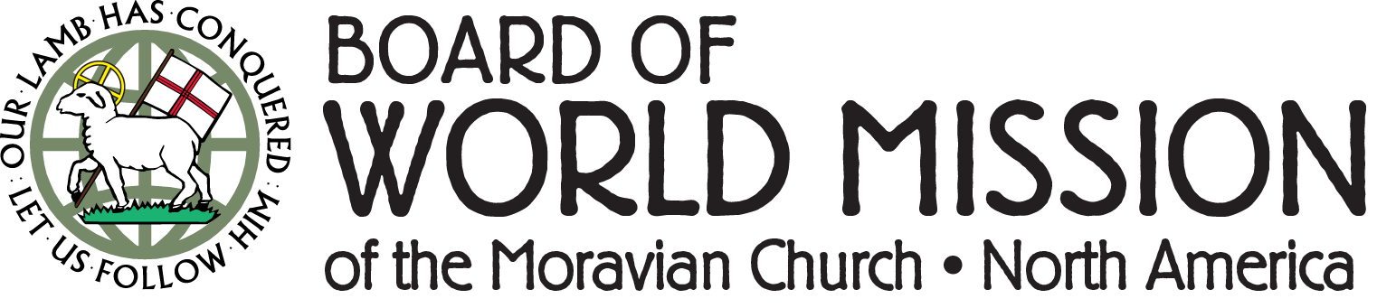

**Did you know?**

The BWM has given out nearly $100,000 through our Mission Grant program to help bring to fruition the plans and projects designed by our global partners? Among the many grants BWM has helped staff a speech therapist at the Star Mountain Rehabilitation Center in Palestine, provided funding to start up a Moravian Laundromat in Peru to help subsidize growing church ministries, supported new mission outreach efforts in Tanzania, and provided resources for church building projects in Cuba and Sierra Leone. The list goes on! As we witness the ongoing success of these efforts, and the life changing impact they are making, we hope to more than double the size of this program by 2023. You can help by signing up to be a recurring monthly donor in support of "BWM MISSION GRANTS" on our website at [MoravianMission.org/give](http://MoravianMission.org/give).  Visit the BWM website to see detailed stories about these many Mission Grants!

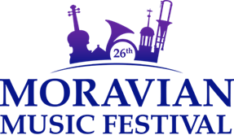

Part 1 of the 26th Moravian Music Festival  
was a worldwide experience of music   
and the connections we enjoy through music.

**ANNOUNCING PART 2  
July 26 – 30, 2022**Bethlehem, Pennsylvania

[**www.moravianmusicfestival.org**](http://www.moravianmusicfestival.org)

Part 1 of the Festival was online, July 18-24, 2021, using YouTube and Zoom, and creating video and virtual chorus and virtual band projects.

There were

* 9 virtual music projects in all,
* 6 full concerts, containing 8 hours of live-streamed or recorded music, devotions, and the word, (several countries participating)
* music by 57+ distinct musicians or musical groups from 5 countries,
* 41 educational and instructional videos,
* 17 hours of social connections and fellowship,
* 12 songs written or arranged, and recorded for the ACTS youth musical theater
* daily connections and lessons for children and youth,
* games and activities for children and youth,
* 8 live educational sessions (again, involving a variety of countries),
* 1 Trivia Challenge
* 1 Instrument Zoo

Concerts are available for public viewing at [Festival Concerts](https://www.youtube.com/channel/UCero445SAF_fSB9-bYWbhkA)

Registration for the 2022 Festival will open in the fall.

[www.moravianmusicfestival.org](http://www.moravianmusicfestival.org)

[www.moravianmusic.org](http://www.moravianmusic.org)

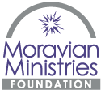

**Grants to be awarded August 13**

What better time to announce ministry grants than the August 13 Festival! Watch for news about the 2021 grant recipients. A record 23 applicants, representing 18 different congregations and agencies from all areas, have requested money from the Field of Interest Funds represented on the [**Moravian Giving Portal**](https://mmfa.info/giving-portal/). Those funds include: Hunger & Thirst, Housing & Shelter, Healing & Health, Clothing, Prison Ministry, and Environmental Stewardship. Thanks to your gifts during the Moravian Day of Giving, we have 4x more money (than last year) to award to some excellent proposals!

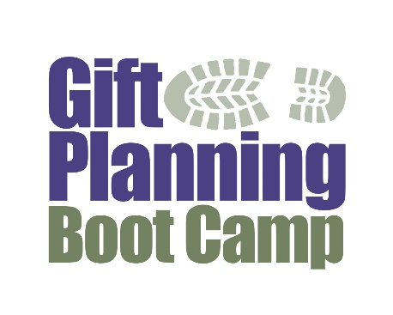

[Click here to learn more and register.](https://mmfa.info/uncategorized/online-summer-learning-series-from-mmfa/" \t "_blank)

**Vince Holbrook**

Director of Communication & Marketing

Moravian Ministries Foundation in America



Crossroads is pleased to offer the following courses this Fall. All courses are offered in person at Moravian Theological Seminary and online, real time through Zoom. Registration and more information is available at www.moravianseminary.edu/crossroads. Contact Dr. Jill Peters at petersj2@moravian.edu with any questions.

*Traditions*, a look at world religions and other Protestant denominations, with the Rev. Dr. Bill Falla on Mondays from 6-9 pm, Sept 13-Nov 1, 2021.

*Creative Worship* with Rev. Maggie Wellert explores what is worship and how we can bring new life to our worship experiences. Thursday 6-9 pm, Sept 9 - Oct 28, 2021.

*Unpacking the Scriptures - Discipleship* with Pam Weiss who leads the discipleship program at First Pres Allentown gives us practical and creative ways to bring people together to explore their faith. This is our Late Fall Course which meets twice a week (Mon and Thur) from 11/4 until 12/2/2021.

Looking ahead:

*Missional Leadership*, Mondays 1/3 - 2/21/2022 Dr. Jill Peters

*Road Hazards* (Congregational Ethics), Thurs 1/6 - 2/24/2022 Rev. Derek French & Dr. Jill Peters

*Story of Christianity*, Mondays 3/7 - 5/2/2022 (Except Holy Week 4/11) Rev. Dr. Bill Falla

*My Journey* (Formative Spirituality) Thursdays 3/10 - 5/5/2022 (Except Holy Week 4/14) Rev. Maggie Wellert

**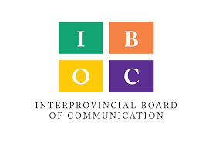**

It's time to pre-order the 2022 Moravian Daily Texts *"The steadfast love of the Lord never ceases, his mercies never come to an end; they are new every morning." Lamentations 3:22, 23*

Pre-ordering for the 2022 Moravian Daily Texts is now open. Through August 13, 2021, the Interprovincial Board of Communication offers a 10% pre-order discount for the 2022 editions, including:

• Paperback: reg. $11.50, preorder $10.35

• Hardcover: reg. $16.00, preorder $14.40

• Large Print: reg. $14.00, preorder $12.60

• Journal: reg. $17.00, pre-order $15.30

• Spanish or German, reg. $11.50, preorder $10.35

• Large Print German, reg. $12.00, preorder $10.80

To receive this special pricing for yourself or a bulk order for your congregation, click through to our website, download the order form or contact Jill Bruckart (jill@mcnp.org) by August 13. Note that you can also pre-order your 2022 Moravian Desk Calendar & Plan Book and 2022 Directory & Statistics at this time.

For more information on our entire catalog and to learn more about the work of the IBOC, visit: https://store.moravian.org/ or call Jill at 1 (800) 732-0591, ext. 38.

The 2022 Moravian Daily Texts ship in November.