**WD News & Notes**

The Newsletter of the Moravian Church,

Western District

**October 2021**

**2021**

Rev. Bruce Nelson, President • 221 E. Mills Drive, Lake Mills WI, 53551 • 920-253-9030 • bruce@mcnp.org • www.Moravian.org

Bruce’s Babblings

*“For surely I know that plans that I have for you, says the Lord, plans for your welfare and not for harm, to give you a future with hope.”* Jeremiah 29:11 (NRSV)

Brothers and Sisters in Christ:

I looked back on what I wrote for my article one year ago today. Here is part of what I wrote: “when I learned of Covid-19 earlier this year, I certainly did not think we would still be having to be cautious in October.” I wrote that a year ago and here we are in October 2021 still being cautious. I could get into some strong words that would probably be pretty divisive but that is not my nature and I will not do that.

What I will do is say this: It is hard to make future plans. I recently returned from a six day vacation from San Francisco with one of my daughters. We had talked about the trip early in 2021. At that point the Covid-19 numbers were pretty bad and we determined that we had better not go. As we got into May and June, the numbers were much better and we decided that we could go as long as we were cautious. By the time late August and early September rolled around, I was wondering if we had made a wise decision. We already had our airfare, hotel and rental car reservations and had both taken time off of work. We decided to go and to just be very cautious. We had a wonderful time and I am glad we went.

But, in the midst of all of this I am aware of how difficult it is to make long range future plans. As our churches think of fall plans, we question what is the safest thing for all of our members. Or, if it is a community event, what is the safest thing for our community? It is a difficult question. I know of couples who have put off wedding plans, or families who have put off memorial services or funerals for loved ones. It is tough to know exactly what to do.

It is at times like this that I am reminded of the words of Jeremiah 29:11 which states, “For I know the plans that I

have for you…” I heard a saying a while ago and I honestly don’t remember the source but it has given me comfort over the years. That saying was, “I don’t know what the future holds, but I know who holds the future.” This saying has carried me several times.

As we continue to live into this autumn season, I would encourage you to continue to make plans but to realize that we may need to change them because the Lord has plans for each and every one of us.

Serving Christ with you,

*Rev. Bruce J. Nelson*

Grant for Lay Ministry

The Western District has received a generous bequest from the family of Rt. Rev. Wil and Ruth Behrend. With some of this gift, your Western District Board has developed the **Behrend Memorial Grant for Lay Ministry**. We are encouraging churches to write requesting a grant for $1,000 per congregation for use with an ongoing or a new **lay-led** ministry.

This grant is open to any congregation or emerging ministry in the Western District and the grant money will be distributed after the local congregation or emerging ministry has filled out the grant application and any other requested materials. GraCarol Jnt application forms have been sent to all congregations and emerging ministries in the Western District. Completed application forms should be sent directly to District President Bruce Nelson either via email ([bruce@mcnp.org](mailto:bruce@mcnp.org)) or via snail mail at: Rev. Bruce J. Nelson, 221 East Mills Drive, Lake Mills WI, 53551.

Church Anniversaries

Oct. 6 London 132 years

Oct. 23 Canaan 140 years

Oct. 31 Lake Auburn 163 years

Clergy & Spouse Birthdays

Oct. 3 Carol Jones

Oct. 16 Jane Harberg

Oct. 16 Dave Sobek

Oct. 20 Martin Avery

Oct. 21 Jane Graf

Oct. 21 Scott Wheeler

Oct. 22 Paul Moran

Ordination Anniversary

Oct. 18 Marian Boyle Rohloff 19 years

The Call Process

Please hold the **West Salem Moravian, Our Savior’s Moravian and the Unionville Moravian** congregations inyour prayers as they continue in the call process.

The District Board continues to be grateful for the leadership of the Joint Board at **Grace Moravian** as they continue to lead their congregation.

Prayer Concerns

We remember in prayer Br. Robert Smith, retired pastor living in Washington, whose his wife Peg Smith “entered her long awaited rest in her Savior” on Tuesday, September 7.

We continue in prayer for Br. Joel Russell, pastor of the Bethel and Goshen Moravian Churches in rural North Dakota, as he continues his recovery from his accident.

You Belong is a developing faith community in Green Bay, WI, grounded in accessibility, inclusivity, love, and compassionate care that seeks to serve families, caregivers, and individuals of all abilities. Learn more about You Belong at youbelongwi.org. Follow us on Facebook (You Belong) and Instagram (@youbelong_wi).

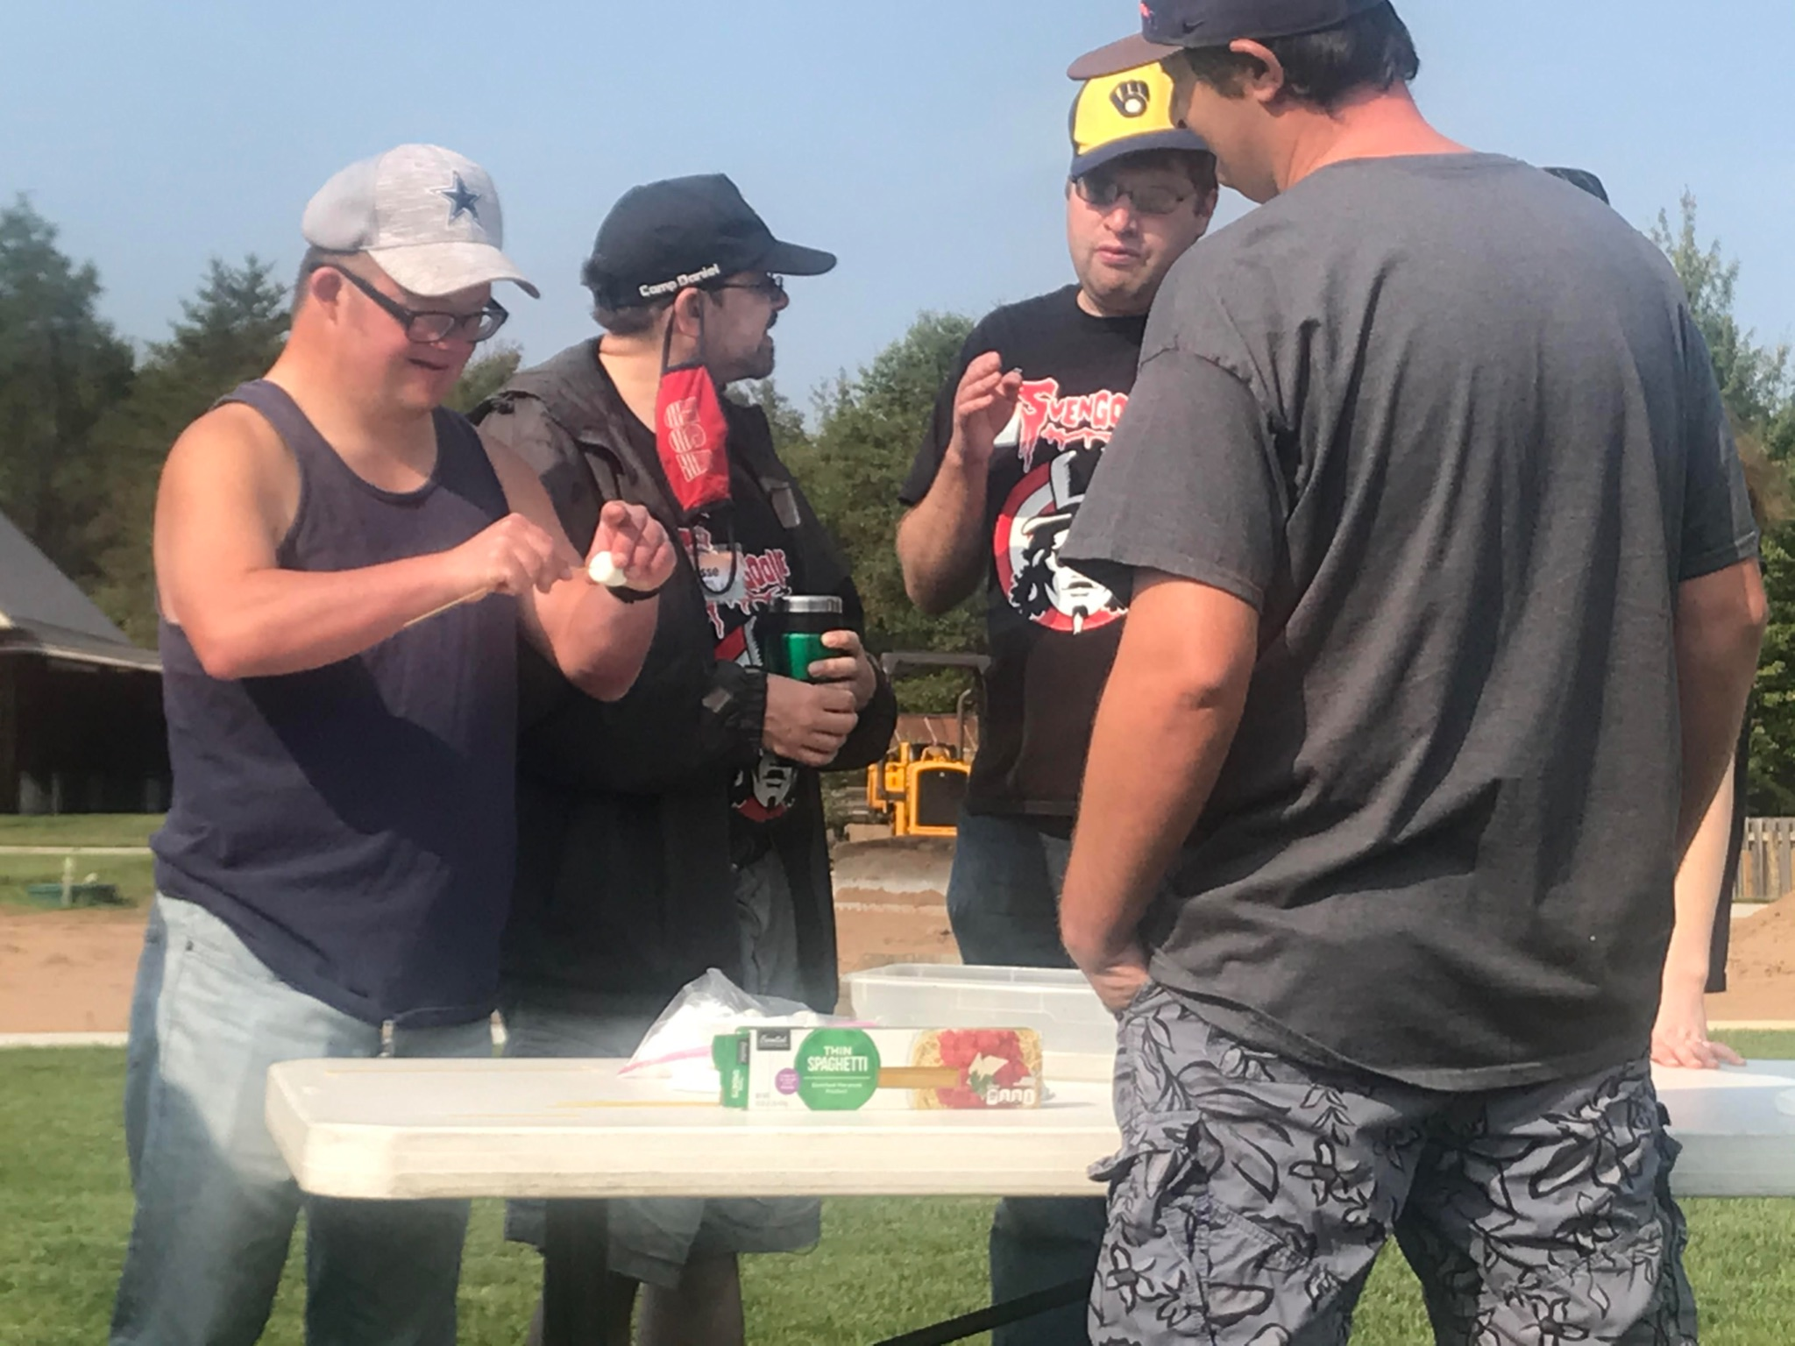

**Pray for us:** Please hold our staff, volunteers, and all of the people we serve in your prayers!

**Connect us:** Help us get connected with individuals and families who might benefit from the uplifting support of our vision and ministries.

**Serve with us:** We want to work together! You can join us by volunteering your time and talents. Check out our mission outreach opportunities at youbelongwi.org OR invite us to blend our gifts together and serve alongside you!

**Build a better tomorrow:** Let’s work together to build a better community for everyone. Invite us into your group, business, or faith community to do an accessibility and inclusion analysis.

**Opportunities to give:** There are a variety of ways to give a gift to You Belong. Give a direct financial contribution electronically at youbelongwi.org or through Venmo (@youbelongGreenBay) or PayPal (info@youbelong.org). You can also mail a check made out to You Belong to 2768 Allouez Ave, Green Bay, WI 54311. To give in-kind donations, view our website at youbelongwi.org to see what contributions we are currently collecting.

\\\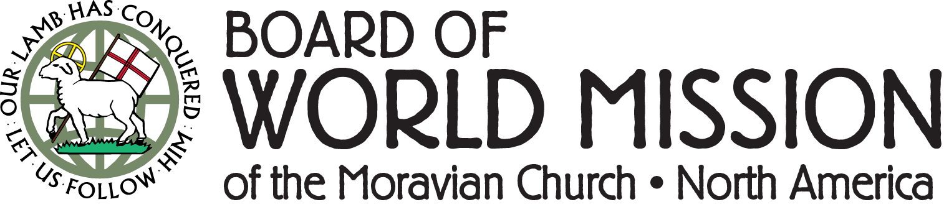

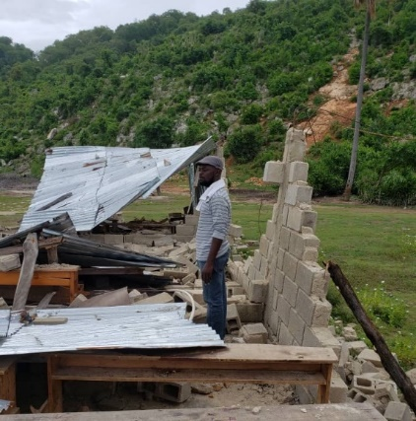The Board of World Mission continues to invite your prayers for all who are suffering from hunger, natural disasters, war, and injustice. Moravian Disaster Response is currently working with our partners on three major areas of concern:

Haiti Earthquake Relief: On August 14th, a devastating 7.2 magnitude earthquake hit southwestern Haiti, causing major damage to two Moravian congregations. Thanks to the support we have received so far, the BWM has sent $17,500 to Haiti. Moravians in the capital city have already sent support teams to the affected areas.

Hurricane Ida: This was a major category 4 hurricane when it made landfall in Louisiana, then continued up from the gulf shore into the northeastern U.S. At this time, we are sending funds to help with emergency outreach and will look toward long-term rebuilding efforts when we can send teams in safely.

Afghanistan Refugee Resettlement: With the withdrawal of military personnel and foreign citizens now complete, many Afghans are seeking to find refuge in the U.S. and Canada. As Christians, we share in a calling to welcome those who are seeking safe shelter. The BWM is partnering with Church World Service to support this urgent need.

Updates on MDR efforts can be found on our website (MoravianMission.org) as well as on Facebook (Board of World Mission) and Instagram (@boardofworldmission).

You can assist the BWM in all of our relief efforts by sending your donations to: Board of World Mission, 1021 Center Street, Bethlehem, PA 18018. You may also make your donation online at MoravianMission.org/Give. Please indicate that your gift is for “MDR.”



Crossroads is pleased to offer the following courses. All courses are offered in person at Moravian Theological Seminary and online, real time through Zoom. Registration and more information is available at www.moravianseminary.edu/crossroads. Contact Dr. Jill Peters at petersj2@moravian.edu with any questions.

*Unpacking the Scriptures - Discipleship* with Pam Weiss who leads the discipleship program at First Pres Allentown gives us practical and creative ways to bring people together to explore their faith. This is our Late Fall Course which meets twice a week (Mon and Thur) from 11/4 until 12/2/2021.

Looking ahead:

*Missional Leadership*, Mondays 1/3 - 2/21/2022 Dr. Jill Peters

*Road Hazards* (Congregational Ethics), Thurs 1/6 - 2/24/2022 Rev. Derek French & Dr. Jill Peters

*Story of Christianity*, Mondays 3/7 - 5/2/2022 (Except Holy Week 4/11) Rev. Dr. Bill Falla

*My Journey* (Formative Spirituality) Thursdays 3/10 - 5/5/2022 (Except Holy Week 4/14) Rev. Maggie Wellert

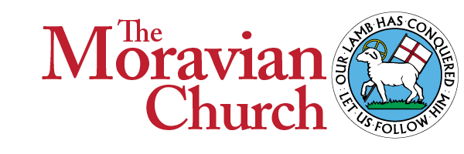

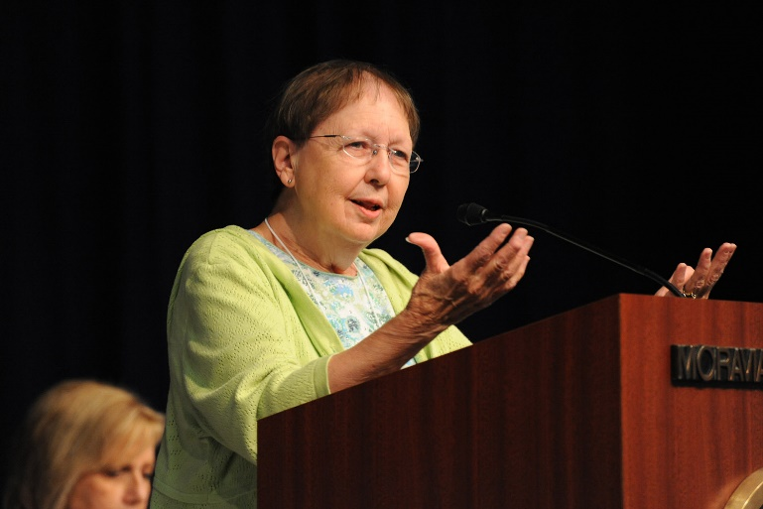

A conversation with The Rt. Rev. Dr. Kay Ward

The Rt. Rev. Dr. Kay Ward will join us for our Steward Sparks session on October 26; Bishop Ward is a writer, former director of continuing education at Moravian Theological Seminary, and retired pastor. She has selected Ezekiel 47:1-12 for our discussion.

### **What does being God’s steward mean to you?**

I am a word nerd so I immediately turned to the dictionary to see how the experts define “steward.” The dictionaries agreed – a steward is a person who manages another’s property or finances. Other definitions identified that person more specifically, i.e the person who handles the domestic concerns on board ship or a flight attendant.

To me, being a good steward means how I manage the gifts that I have been given – time, talent or treasure.  But what does it mean to be God’s steward? From my dictionary study, being a steward means that I am to manage, care for, and protect someone else’s possession. In this case, that someone else is God. Being God’s steward uses the possessive. We are to manage, care for and protect what is God’s. For me, that little apostrophe changes everything.

To be God’s steward is a bigger, grander calling. The call begins with God. God creates, gives and supplies our needs. We are called to act as the caregivers of all that God provides. That little apostrophe puts us in right relationship.

This is awkward to think about and all I can think of are trivial little moments that happen. I like to think of myself as a generous person. I like to think that I am motivated only by serving or helping someone else but time and time again, when I do or give something, I get more than I ever give. Here is an example.

When it is our turn to help serve and supply desserts for those who come to the community meal at our church, I pack a batch of brownies and head to the church. A good feeling is certainly reward enough but I usually go home with a hot meal and occasionally a dozen fresh farm eggs that are brought by some of our guests.

### **What excites you about what God is doing through the collective stewardship of the Ebenezer and Watertown Moravian Churches?**

Every Monday of the year, these two congregations serve a hot meal for anyone who comes. With Covid, we could no longer invite folks into the church but we have been able to provide a meal and a bag of groceries to folks who drive up. As many as 300 folks have been served and groups take turns helping to serve and provide desserts to go with the meals. The exciting part for me is seeing ministry in a non-judgmental way, actually changing the way that we see our guests. Those who participate no longer see people just as those who are in need but begin to see them as neighbors.

### **What’s one goal you have for yourself as a steward?**

As I was thinking of how to respond to this question, I kept thinking of a hymn “Touch the Earth Lightly” (Moravian Book of Worship #655)

**Touch the earth lightly, use the earth gently,  
Nourish the life of the world in our care.**

When my husband and I were younger, we camped in the beautiful boundary waters of Minnesota, enjoying the pristine beauty of the wilderness. The unwritten rule of staying there was that you left the campsite in better condition than when you arrived. That’s what I would like to do – I would like to leave the earth a little bit better than it was when I arrived. I don’t think that is possible but reusing, recycling and restoring what I can is a start. Holding my possessions lightly as I care for what is already God’s is a worthwhile goal.

## **Register now!**

How: Register on Zoom for one, several, or all of the sessions!  
Link: <https://us02web.zoom.us/meeting/register/tZcrdeGqqD0pG9clKqNY3KmdhZJfQyMeuGtN>  
Password: MMFA2021

For more information, please contact Laura at lwatson@mmfa.info or 336-725-2589. We look forward to sparking stewardship, together!