WD News & Notes
The Newsletter of the Moravian Church,
Western District

January 2022

Rev. Bruce Nelson, President 221 E. Mills Drive, Lake Mills WI, 53551 920-253-9030 bruce@mcnp.org www.Moravian.org

Bruce’s Babblings
“For I know the plans I have for you, declares the Lord, plans to prosper you and not to harm you, plans to give you hope and a future.” Jeremiah 29:1

Brothers and Sisters in Christ:

Greetings in this new month and New Year! I hope you were able to spend at least a portion of your holiday with loved ones and/or family and that you found a time of refreshment and joy in what can often be a difficult time.

As we begin a New Year often this is a time to set goals, both personal and joint board, and to make New Year’s resolutions. I have never been one for New Year’s resolutions but I do tend to set annual goals. These goals are often something I tend to keep to myself. Usually they are a mixture of personal and professional goals. They are goals that hopefully help me to be a better version of myself from the previous year.

In spite of setting goals, I often find out that my goals may or may not line up with what God has in mind for me. Also in this time of Covid when we aren’t sure about travel plans or how much we should be out and amongst people, sometimes our goals need to be fluid or flexible. I also pray in the midst of my goal setting that my goals may be something that brings glory to God. So, I will continue to make goals for myself and to try to attain those goals but I will also be open to the plans that the Lord has for me. If I set goals AND am open to what the Lord has in store for me, it will make me a better person.
Serving Christ with you,
Pastor Bruce J. Nelson

Emerge 2022
Mark your calendars as EMERGE 2022 is just around the corner. Come be a part of this empowering event to advance the kingdom of God.

You will learn skills and receive tools to grow an existing ministry, start a new ministry, or start a new church plant. You will also be a part of a team that will do periodic check-ins to ensure progress, provide feedback, and give encouragement.

Emerge 2022, Saturday, February 19, 2022, 9:00am - 2:00 pm (EST) via Zoom. Call-in options will be made available.

Register for your free ticket via the link below.
https://www.eventbrite.com/e/emerge-2022-tickets-208111686657

We pray you will be inspired and encouraged by the video link below:
https://www.youtube.com/watch?v=375ljw1Oh1k&t=10s
With Gratitude,
Rev. Sanette Fleming, Bro. Ben Ingebretson, and Rev. Christie Melby-Gibbons
Grants to help you feed the hungry
Your Moravian Ministries Foundation in America (MMFA) is excited to announce a special 2022 grant cycle for our Hunger and Thirst Field of Interest Fund. Thanks to an incredibly generous donation, we have an extraordinary opportunity to award grants from $10,000 to $25,000 to Moravian congregations, fellowships, emerging ministries, or agencies who want to create lasting change within the food and water insecurity landscape. For more information on how to apply visit https://mmfa.info/grant/ or reach out to Laura Watson 336.725-2589 or lwatson@mmfa.info.

Church Anniversaries
Jan. 1st Chaska 163 years
Jan. 1st Waconia 106 years
Jan. 20th Wis. Rapids 132 years
Jan. 30th Sturgeon Bay 157 years

Ordination Anniversaries
Jan. 18th Terry Weavil 45 years

Clergy & Spouse Birthdays
Jan. 2nd Greg Behrend
Jan. 4th Karen Krauss
Jan. 6th Holly Weavil
Jan. 7th Bob Volpe
Jan. 10th Larry Christianson
Jan. 12th Bob Smith
Jan. 22nd Jackie Bell
Jan. 23rd Matthew Knapp
Jan. 24th Terry Weavil
Jan. 27th Betsy Miller
Jan. 30th Faith Fliegel

The Call Process
Please hold the West Salem Moravian, Our Savior’s Moravian, Unionville Moravian, and Canaan Moravian congregations in your prayers as they continue in the call process.

Rev. Staci Marrese-Wheeler, serving as pastor of the Lakeview and Glenwood Moravian congregations in Madison, WI, has accepted a call to serve half-time as Community Relations Pastor in conjunction with Common Grace, a new federated congregation on the east side of Madison. She will conclude her ministry at Glenwood on January 9 and begin her new call on January 23. She will continue her half-time call to serve at the Lakeview congregation. Please be in prayer for Staci, her spouse Scott, their family and both congregations during this transition.

Rev. James T. Hicks, retired pastor living in Green Bay, WI, concluded his appointment serving part time as pastor of the Daggett Moravian Church in Daggett, MI on December 31. The church extends its gratitude to Jim for his faithful service to this congregation and the wider province.

The District Board continues to be grateful for the leadership of the Joint Board at Grace Moravian as they continue to lead their congregation.

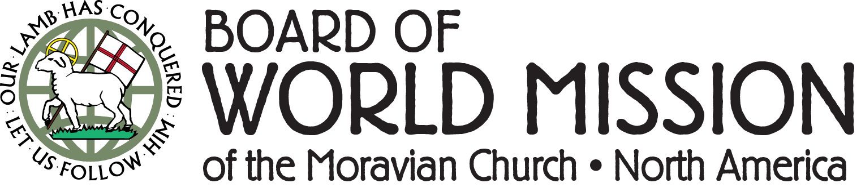

In the early days of a new year, many of us are looking to make and stick to resolutions. We take the opportunity for a fresh start to renew a commitment, or to start something new. The challenge is always.... How long will we stay "resolved"?
At the BWM, we look to the drawing of our yearly watchword as a spiritual grounding of our work to help us meet our purpose of building relationships through Mission Outreach and Mission Engagement to be faithful to the Great Commission and the Great Commandment.
With that in mind, we wanted to share with you the BWM Watchword drawn for 2022:
"Whoever serves me must follow me, and where I am, there will my servant be also." John 12:26
As we look ahead to the new year, we will seek to follow, even as we look to lead several important initiatives. In this year the BWM invites your prayerful support and participation in upcoming ministries. Just a few of the plans we are "resolved" to complete this year include:
● A conference for Spanish-speaking Moravian partners to all come together to share and fellowship.
● Sponsoring / hosting several mission and service retreats at our Moravian Camps
● Continued coordination of disaster response efforts in many communities
● Implementation of pastoral and lay leader training with Mission Area and Mission Province partners
Resolutions are often ambitious, and most likely completed when shared with others for support and accountability. So, come, follow along with us this year!

Upcoming Crossroads Courses: Story of Christianity

Mondays 6-9 pm March 7 - May 2, 2022 (except Holy Week 4/11)

Instructor: Rev. Dr. William Falla
In-person instruction (tentative), as well as real-time distance learning via Zoom

Price $240 Learn More & Register

MY JOURNEY/OUR JOURNEY Thursdays 6-9 pm March 10 - May 5, 2022 (except Holy Week 4/14) Instructor: Rev. Maggie Wellert
In-person instruction (tentative), as well as real-time distance learning via Zoom

Price $240 Learn More & Register

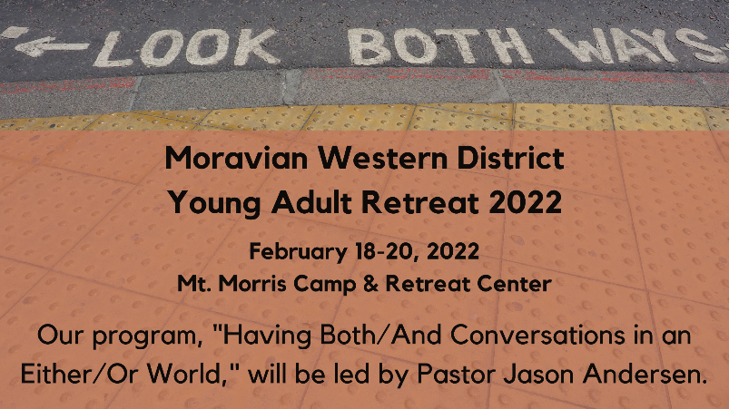

Western District young adults (ages 18-30ish) are invited to spend the weekend of February 18-20, 2022 at Mt. Morris Camp & Retreat Center to learn and fellowship together. Program will be led by Pastor Jason Andersen and will explore how to have Christ-like attitudes and mindsets when we interact with people with whom we disagree. The weekend will also include outdoor activities, games, conversation, and more.

The cost of this year’s event is $50, $75, or $100 (pay what you can), which includes all food and lodging. Please email sylviachauser@gmail.com to receive the registration link or to learn more about the retreat.

