WD News & Notes
The Newsletter of the Moravian Church,
Western District

September 2022

Rev. Bruce Nelson, President 221 E. Mills Drive, Lake Mills WI, 53551 920-253-9030 bruce@mcnp.org www.Moravian.org

Bruce’s Babblings
Greetings on this September day! The fall season always used to be one of my favorites. I like the fall colors and I like some of the tastes and smells of the fall season. But, as I have gotten older, I remember what comes after fall and because of that, I don’t seem to enjoy fall as much as I used to.

Fall is a time when church programming usually ramps up a bit from the summer season. For many of our churches Sunday School is back in session, Bible studies resume meeting, confirmation classes get going again, and some other activities that took a summer break begin once again.

This September many of our pastors from the Northern Province will be taking part in a Racial Justice Pilgrimage as we travel to Montgomery, Alabama. This has been a life-changing experience for those who have already done it. At this point, this particular pilgrimage is open only to clergy but there is a good chance there will be pilgrimages for lay people in the future. For our pastors who are going, I look forward to sharing this experience with you. For those who are not going, you are missing out on a wonderful opportunity to learn and grow.

I want to talk for a moment to the lay people in the churches that have a pastor going to the Racial Justice Pilgrimage. Your pastor will probably come back a little fatigued as the learning and the experience is intense. I would encourage you to think about this as a learning and growing experience. When I was in the parish and attended continuing education events, I would often tell the lay leaders of the church that if the continuing education event does its job, I should come back as a different pastor. I am not going to say that your pastor will come back different, but it is possible that he or she might come back with some new ideas.

Whether your pastor is or is not going on the Racial Justice Pilgrimage, I would encourage you to pray for those who are going.

As I travel around the district (I am traveling a bit more but still being cautious), I hope to see you in the pew on some Sunday morning! Serving Christ with you,
Rev. Bruce J. Nelson
On behalf of the Western District Executive Board

Northern Province Churches in the Call Process or Without Pastors
Battle Hill, Union, New Jersey
Central (Associate Pastor), Bethlehem, PA
Covenant, York, PA
York First, York, PA
New Dorp, Staten Island NY
Tremont Terrace, Bronx, NY
Trinity, New Carrolton, MD
Our Savior’s Moravian in Altura, Minnesota
Berea Moravian Church in St. Charles, Minnesota
Unionville Moravian in Unionville, Michigan
West Salem Moravian in West Salem, Illinois
Good Shepherd in Calgary, Alberta
Heimtal, Alberta
Edmonton, Alberta

Additionally: two congregations that are not in the call process but are currently without pastors are Grace Moravian in Westland, Michigan and Daggett Moravian, in Daggett, Michigan.

A Personal Word from Our District President
On behalf of my entire family, I would like to thank those of you who remembered or in any way reached out to my family following my mother Carita Nelson’s death and celebration of life. We were overwhelmed with cards, notes, phone calls, and many other acts of kindness. We thank those of you who attended her memorial service and all that you have done for us. May God continue to bless all of you!
Sincerely,
Bruce Nelson

rEcess Respite Event

You Belong is hosting a respite event on October 15th from 10 a.m. to 4 p.m. This is a program for Green Bay-area families who have a family member experiencing disability. Participants will experience an empowering and encouraging day full of activities, while family members are encouraged to enjoy a day of self-care.

Registration is now open for participants and volunteers! We encourage Moravians to spread the word and sign up to be part of this meaningful experience. If you have never participated in one of You Belong’s ministries, this is a great way to get acquainted with our team and our work. The event also includes a meal for all participants and volunteers.

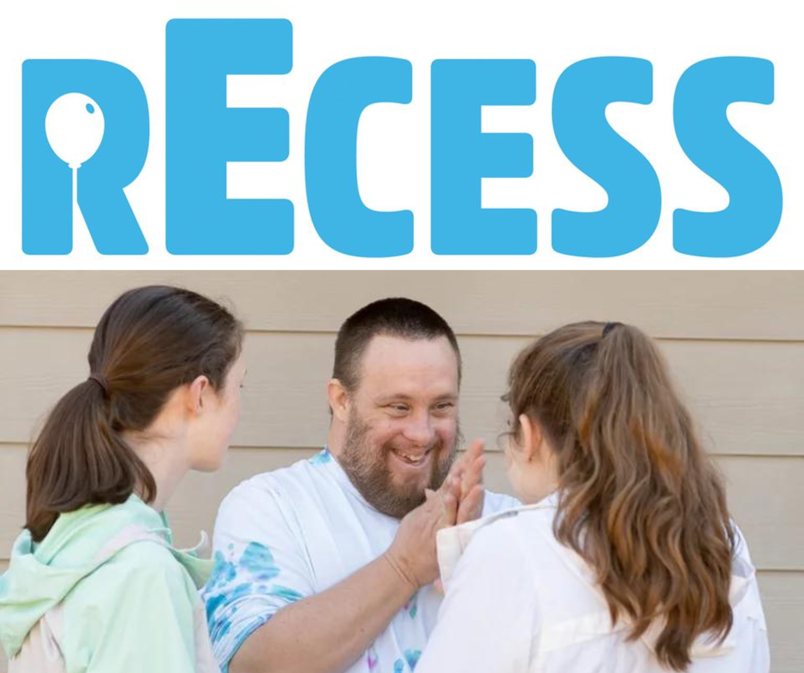
Learn more and register on our website:
YouBelongWI.org/projects-8

Church Anniversaries
Sept. 10 Daggett 111 years
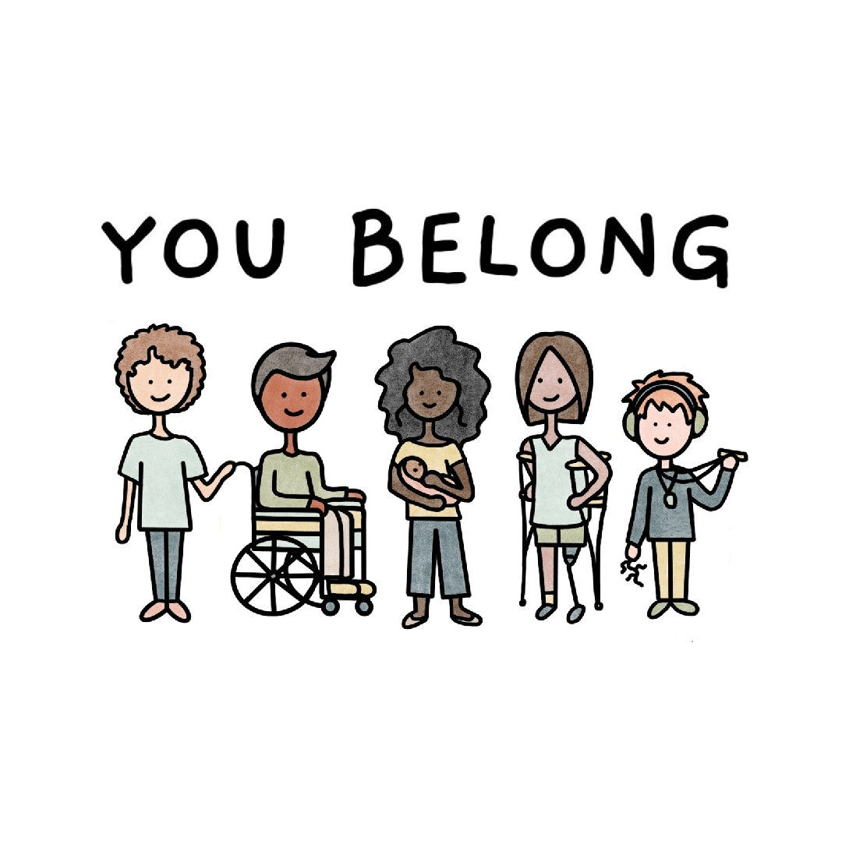
Sept. 11 Watertown 168 years
Clergy & Spouse Birthdays
Sept. 13 Marian Boyle-Rohloff
Sept. 21 Rita Andersen
Sept. 22 Jason Andersen
Sept. 27 Sharon Benson
Sept. 27 Peg Chemberlin

Ordination Anniversaries
Sept. 5 Peg Chemberlin (40 years)
Sept. 6 Christie Melby-Gibbons (13 years)
Sept. 7 Vicki Jens-Page (14 years)
Sept. 10 Olaf Andersen (55 years)
Sept. 12 David Glasser (40 years)
Sept. 15 Barry Lehman (47 years)
Sept. 24 Jane Gehler (16 years)
Sept. 29 Sharon Benson (25 years)

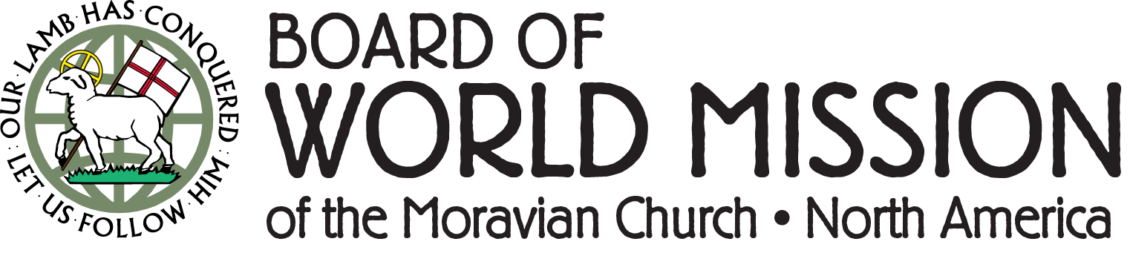
Summer “break” is an interesting thing to think about once you are out of school... If you, like me, live in Wisconsin, summers are short and, rather than taking a break and slowing down, summer feels more like a sprint as I try to accomplish as much as possible in these warm and long days. For BWM staff this also means fanning out and attending our different summer camping programs. BWM staff and board members will collectively serve more than a dozen weeks at our Moravian summer camps this year. Personally, at the time of writing, I have just completed back-to-back weeks at Chetek (Western District) and Camp Hope (Eastern District) for their senior high programming. It was inspiring to be able to serve as a counselor for such engaged and passionate young adults who truly live out the challenge of 1 Timothy 4:12 to "be the example" of what God calls the world to be.
In addition to staffing camps with BWM employees, we also facilitated camper exchanges, including helping two campers from Florida to attend Chetek in Wisconsin and then covering the travel expenses for a camper from the Western District to attend Camp Hope. These exchanges are invaluable as relationships are formed amongst developing leaders. At each camp, conversations were held about opportunities for mission service as part of vocational discernment and general growth. As a result, a new crop of names has been added to our list of potential mission team participants in the near future. I am excited by the passion apparent in our church for this important work.
Learn more about the Board of World Mission at MoravianMission.org or find us on Facebook and Instagram.

Interprovincial Ministers’ Convocation
Approximately every seven years Northern and Southern Province clergy, active and retired, gather for the Interprovincial Ministers’ Convocation (IPMC) for a time of learning, fellowship, and renewal for their ongoing service in the ministry of Jesus Christ.

With the support and approval of both PECs, this year the IPMC will be held October 18-21, 2022 at the Claggett Center in Adamstown, Maryland. The presenter is the Rev. Dr. Luke Powery, professor of homiletics and dean of Duke University Chapel. A grant from the Lilly Foundation’s Thriving in Ministry initiative covers most transportation costs, meals, and lodging, with only a minimal registration fee of $250 per person.

We strongly urge congregations to support their pastors’ presence at the Convocation. How? By encouraging attendance, assisting with expenses, and coordinating lay-led worship on the Sunday following the Convocation. This support is not only for the sake of our pastors, but more especially for the sake of the mission of the Moravian Church and its call to ongoing service in the world.

These are challenging times, including the pandemic, gun violence, blatant and violent manifestations of discrimination and racism, and so much more. The difficulties are great for everyone, and especially for pastors, who must cope not only with the same challenges, but also care for the challenges facing members of their congregations and communities.
As a result, recent national research shows that mainline clergy are experiencing high levels of exhaustion and stress—mental, emotional, and spiritual. Research also shows that gatherings for renewal and shared fellowship are crucial for the well-being of pastors and their work on behalf of the gospel. In Jesus’ own ministry, after the 12 returned from their mission of sharing the good news, Jesus called them away to time apart (Mark 6:30-32). In the same way we call our pastors, active and retired, to this important time in the life of the church.

Pastors attending the Northern Province Pilgrimage toward Racial Justice and Healing in mid-September are urged to attend the Convocation as well. These are very different events, with different purposes: both are important and necessary. The Pilgrimage will require significant physical, emotional, and spiritual investment—hard and important work. The Interprovincial Convocation provides the “get away” to which Jesus calls his disciples and which is also important and necessary. In fact, doing both—the hard work of the Pilgrimage followed by Jesus’ calling to get away for a while—can provide clergy with the spaciousness and support for processing the Pilgrimage and emerging more rested and renewed for the work ahead.

Please support the attendance of your pastoral leader to this crucial Interprovincial Ministers’ Convocation October 18-21, 2022.
With hope in the promises of God,
Elizabeth Miller, David Jones,
Melissa Johnson, Bruce Nelson

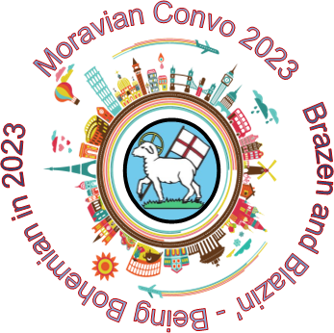
Moravian Young Adult Convo

Brazen and Blazin’…
Being Bohemian In 2023
July 3 – 11, 2023
A Spiritual Pilgrimage following
in the steps of the early Moravians.

Registration deadline is September 15!

8 days - Moravian Heritage Pilgrimage - Young Adults 18-25 years old. Be bold in your faith, following in the Brazen and Blazin’ steps of the early Moravians. Experience Bohemian life as you travel to Prague – the home of Bethlehem Chapel, Husinec – the birthplace of Jan Hus, and Tabor – where the Hussite movement began. Engage in mission outreach with Czech Young Adults in Kunvald – the birthplace of our church, worship at Chalice Rocks, walk the Moravian path of spiritual renewal in Herrnhut, Germany, and sing your favorite hymns in Dresden, Germany.

Young Adult Convo Costs $2650.00 (USD) Registration Fee Includes: Flight Housing Most Meals (two meals on your own) In Country Travel and Transit Program and Mission Outreach Trip (Flight) Insurance Join the next Young Adult Convo, Brazen and Blazin’...

Being Bohemian in 2023. The past was wide open and the future still is...

For More Information and Registration Link go to https://www.moravian.org/ ccd/2023-young-adult-convo/
Payment may be made in up to three installments: Deposit $885.00 September 15, 2022 Second Payment $885.00 February 15, 2023 Final Payment $880.00 June 1, 2023 Check out ways to raise funds to attend Young Adult Convo 2023 at https://www.moravian.org/ccd/2023-young-adult-convo/ Don’t let money keep you for experiencing this unique Spiritual Pilgrimage.

Improving our relationship with money
Sign up by 9/26. Classes begin 10/11.

In his book God Vs. Money, Clif Christopher writes, “I began to explore where our priorities were and whether our strivings were moving us closer or farther away from a relationship with our Creator.”

Are you also thinking about what you value, what brings you happiness, and (hopefully) what brings GOD happiness? When it comes to money, are you working to make smart decisions while also wanting to do good with it? Unfortunately, our relationship with money can be a source of real stress and tension. It’s hard to overcome our culture’s messages of hoarding, fear, and “it’s all mine and I need more.”
Yet as stewards we know all we “have” is actually God’s, entrusted to us by our Creator to be used faithfully for God’s purposes, not our own.
So, what are we to do? Take a class, of course!
This fall MMFA is delighted to offer Freed Up, a six-week financial stewardship training program that offers current resources to help guide and equip people of faith to manage money in healthier ways, through Biblical wisdom. Freed Up is for anyone in any financial situation, not just those in crisis.

Utilizing an app to deliver videos, and readings, Freed Up addresses all components of financial stewardship, including:
- Earning
- Giving
- Saving
- Spending
- Debt
We are offering two virtual FreedUp opportunities on Tuesdays this fall from October 11 to November 15; one from 12-1 pm and the other from 7-8 pm (Eastern time). Complete each week’s content at your own pace and then join the group on Tuesdays for conversation and learning together. We are able to offer Freed Up for free to 100 people this year; you read that correctly…. for free!

