WD News & Notes
The Newsletter of the Moravian Church,
Western District

February 2023

Rev. Bruce Nelson, President 221 E. Mills Drive, Lake Mills WI, 53551 920-253-9030 bruce@mcnp.org www.Moravian.org

Bruce’s Babblings
Brothers and Sisters in Christ:

“Be still before the Lord, and wait patiently for him.” Psalm 37:7

We come to the month of February, the shortest month of the year but a very important month. It is often in February when we begin our Lenten journey (sometimes it is March but it is often February). The amount of daylight in the northern hemisphere continues to increase. For those of us in the upper Midwest, we can look forward to the temperatures warming up a bit, although this year the temperatures have not been too cold.

I am about to complete my sixth year as the President of the Western District Executive Board. There have been lots of changes in those six years. The first things that come to mind are Covid 19, zoom meetings, travel, and then no travel, and then some travel, and then lots of travel plus meetings. I also have noticed a clergy shortage and an aging clergy.

I have mentioned many changes above but I believe the biggest change I have seen in the last six years is a lack of patience. Before you think I am just admonishing you, I include myself in this lack of patience. I remember when I was a child or a young adult, you would get a letter from someone and you would hope to get a letter back in a few days. You would have someone try to call you on the phone. If you weren’t there, they would just try you later. There were no such things are answering machines back in that day. Once we did get answering machines, we would expect a call back sometime soon, but not necessarily on the same day.

Today, we (myself included) call to text or email someone and if we don’t hear back in a few hours (sometimes minutes) we become impatient. I think we need to look again at some of the examples of Jesus taking time to retreat, to go away, to be alone to commune with his father. Jesus was not bothered by phone calls or texts or emails. Rather he took time to just be in silence. When is the last time you took some moments to just sit in silence and waited patiently on the Lord? I know that there are times when I bypass this and interestingly enough it is at those times when I feel the furthest from God.

I encourage you to be patient, to wait upon the Lord and that you allow and encourage others to do the same.

Serving Christ with you,
Bruce J. Nelson

Northern Province Churches in the Call Process or Without Pastors
Battle Hill, Union, New Jersey
Central (Associate Pastor), Bethlehem, PA
Covenant, York, PA
York First, York, PA
New Dorp, Staten Island NY
Tremont Terrace, Bronx, NY
Trinity, New Carrolton, MD
Our Savior’s Moravian in Altura, Minnesota
Berea Moravian Church in St. Charles, Minnesota
West Salem Moravian in West Salem, Illinois
Good Shepherd in Calgary, Alberta

Additionally: two congregations that are not in the call process but are currently without pastors are Grace Moravian in Westland, Michigan and Daggett Moravian, in Daggett, Michigan.

Camp Dates for 2023
Chetek: July 16-22
Winmor: July 23-29
Junior: July 30-August 3

Church Anniversaries
Feb. 2 Bethel 132 years
Feb. 3 Morongo 66 years
Feb. 13 Unionville 152 years

Ordination Anniversaries
Feb. 15 Jane Harberg 31 years
Feb. 26 Kurt Liebenow 28 years

Clergy & Spouse Birthdays
Feb. 15 Rebecca McDonald
Feb. 19 Amy Gohdes-Luhman
Feb. 26 Olaf Andersen

Seed Distribution in Honduras and Nicaragua
It’s not exactly planting season here in North America, but at the Board of World Mission, we have seeds on the brain! That’s because much of our recent disaster relief work has been focused on providing bean and vegetable seeds for replanting after disasters have wiped out existing crops in Honduras and Nicaragua. After nine months of heavy rains and flooding, we continue to receive reports of families in La Mosquitia living on one meal per day and often surviving on fish that they are able to catch from the riverbanks. Thanks to generous BWM donors, we have provided 13,000 pounds of bean seeds, which will be distributed to about 650 families. The seeds will be planted by mid-February and harvested in March or April. If it is unaffected by floods or insects, this will be the first harvest of a major food crop in the last twelve months. We are also pleased to report that, thanks to Sturgeon Bay Moravian Church and a North Carolina organization called Seed Programs International, hundreds of families will also soon be able to plant watermelon, cabbage, tomatoes, kale, and more. Many thanks to Brother Rick Nelson and our Honduran and Nicaraguan partners, who have been instrumental in coordinating these efforts. Stay updated on these Moravian Disaster Response efforts and other Board of World Mission projects on our website, MoravianMission.org.

Crossroads 2023 Spring Courses
Note: All courses are in person for those who are able AND also real time on Zoom.

Traveling Mercies - Congregational Care with Dr. Jill Peters, Greg Krausz and Diane Kareha
Mondays, 6-9 pm, Mar 6, 13, 20, 27, (Not meeting Holy Week 4/3), Apr 10, 17, 24, May 1 Texts:
TBA. Zoom Option is always available for real time distance learning.
Traditions - World Religions and Protestant Denominations with Rev. Dr. Bill Falla
Thursdays, 6-9 pm, Mar 9, 16, 23, 30, (Not meeting Holy Week 4/6), Apr 13, 20, 27, May 4
Texts: TBA. Zoom Option is always available for real time distance learning.

As a preview for next year:
Fall 2023/Winter 2024 Projected Courses: The following courses will probably be offered next academic year: Compass, Creative Worship, Missional Leadership, Road Hazards - Congregational Ethics, Discipleship, Teaching and Contextual Outreach.

For more information, Contact Jill Peters at petersj2@moravian.edu or go on the website at www.moravianseminary.edu/crossroards

February IBOC Highlights
As Lent approaches, the IBOC offers Readings for Holy Week on Sale for a limited time. This book/CD set takes participants through Jesus’ final week before his Crucifixion and Resurrection. Music Edition sale price is $10.50; Large Print $7.50; 5-CD set 24.95. Also available in a bundle that includes CD set and either book.
Rev. Brian Dixon’s latest book filled with prayers, poems and parable, Losing Light-Walking by Faith but Wanting More is available through the IBOC. Read his latest book that completes his moving pictures duology that started with his first book, Keeping Time: Dances to the Beat of a Different Drummer. Cost: $12.95.
Log onto store.moravian.org to order.

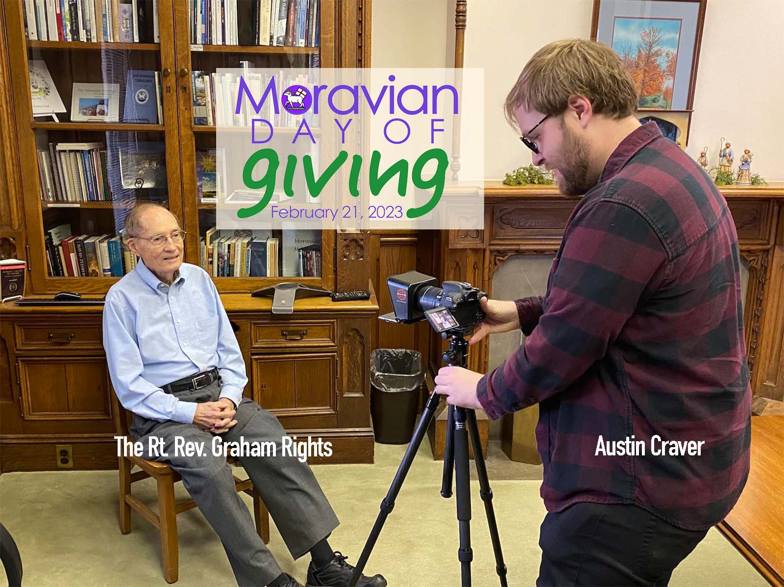

Bishops Graf and Rights on the
Moravian Day of Giving (February 21)
If you want to better understand the importance and value of the Moravian Day of Giving, just listen to these recorded messages from The Rt. Rev. Paul Graf and The Rt. Rev. Graham Rights. They are our sponsoring bishops for the third annual Moravian Day of Giving. It's the one day we ask your help to replenish grant-making field of interest funds by giving above and beyond your tithe or pledge. The Moravian Ministries Foundation in America puts incentives in place for gifts to both congregations and grant-making funds, so your gifts go further on this day than any other. Special thanks to Austin Craver (Commission on Congregational Development), Sylvie Hauser (Board of World Mission), and Mike Riess (Interprovincial Board of Communication) for producing these videos.
Watch Bishop Graf Video Now

Watch Bishop Rights Video Now

Moravian Day of Giving is 2/21/23
Imagine the possibilities! Think of all the good your congregation could do with $10,000! The one U.S. Moravian congregation or fellowship with the highest level of participation on this year’s Moravian Day of Giving will receive $10,000.00 (unrestricted).
The congregation with the second highest level of participation will receive $5,000.00 and the third highest level of participation will receive $2,500.00. Help your congregation do more good by making a gift on Tuesday, February 21, 2023 to your congregation on the Moravian Giving Portal. - Vince Holbrook

