Ideas from Moravian Congregations on Celebrating Moravian Day of Service
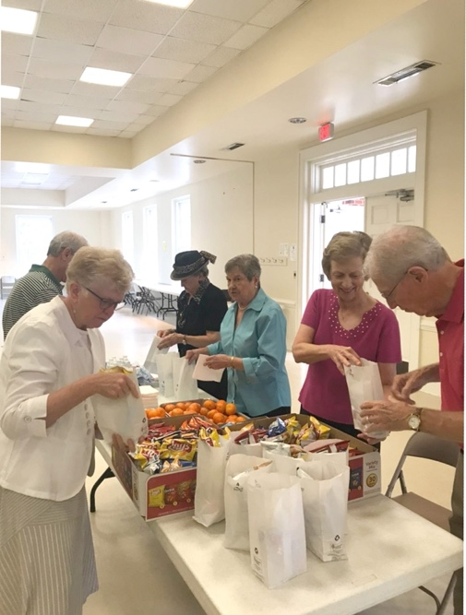
In Watertown, Wisconsin, members of Watertown Moravian Church chose from one of three opportunities: deep cleaning the kitchens that support the Loaves and Fishes community meal that feeds about 100 people each week; removing weeds from the prayer labyrinth at Mt. Morris Camp and Retreat Center; and handing out 100 bottles of water in support of the Watertown Rummage Sale day. Working with current ministries offered an affirmation and encouragement for continuing support for those ministries, while handing out water provided a direct connection to the community at large.
Members of Clemmons Moravian Church identified the Winston-Salem Rescue Mission’s daily bagged lunch program as a mission to support. So, following worship on Sept. 15th, approximately 50 volunteers prepared lunches including peanut butter and jelly sandwiches, chips, granola bars, fruit and bottled water. The food was provided by the church’s Womens’ Fellowship Circle 3. Explained Clemmons’ members, “This outreach was a good reminder of how we are called to provide for those in need.” Those participating are considering continuing this as an ongoing outreach project.
When considering their participation in the Moravian Day of Service, the Mission and Outreach committee at Christ Moravian Church in Calgary, Alberta, quickly determined an important need in their community was to support those in the process of aging. They came up with the idea to provide an information session to help answer some of the questions around aging, particularly around support and services that are available. Their session, which focused on “Aging in Place,” began with a pay-what-you-can lunch and featured speakers from a variety of senior-focused community organizations, the City of Calgary and the Province of Alberta. The response was overwhelming, with 130 community members attending. Attendees were grateful to receive the information and support that was provided at the seminar and expressed appreciation for the warm and caring community they found at Christ Moravian Church. “We were glad to have provided an affirming church experience for all who attended as we work be an example of God’s transforming love in the world,” said Christ member Donna Gordon. Note: Christ Church, which celebrated its 50thanniversary in 2019, is considering making these aging sessions an ongoing ministry.
Palm Beach Moravian Church in Florida is a diverse congregation with natives from Jamaica, Nicaragua, Antigua, St. Kitts, St. Thomas, Barbados and the USA. So for their Moravian Day of Service effort, they hosted a Cultural Exchange for the congregation and the community. Congregation members shared different foods, juices, candies and pastries from various countries, wore clothing unique to their cultures, danced to culture music and shared facts about their homelands. “The food, fellowship and fun were astounding; it was a joy to see the community members indulging, interacting and participating in the evening’s activities,” said Evette Campbell of Palm Beach. “We learned that there is strength and unity in diversity and while we are uniquely different, there is more that unites than divides.”
The staff of Raleigh Moravian decided to extend the Day of Service to a weekend of service opportunities. This allowed more of our membership to find a time and location that fit their interests. Members could participate in one of two service opportunities on Saturday morning, September 14, and in one of two service opportunities on Sunday morning, September 15.
On the Saturday before the Day of Service, a team of 12 planted three fields of collard greens for The Goodwill Community Farm in Durham, which provides fresh produce to local food banks. The team reported a wonderful experience and would like to make plans to return in the near future. Team member Carol Husch commented that, “It was the most fulfilling hard work I have done in a long time” and her husband Barrie added, “The farm manager was amazing and made the work fun!” Both echoed, “We would love to go again!”
At the same time, a group of 19 Raleigh members worked specifically with the Mobile Market initiative of the Interfaith Food Shuttle in Raleigh, setting up, sorting and running a mobile grocery store at Martin Street Baptist Church. The team reported a busy, but very worthwhile experience. They were able to meet the immediate food needs of neighbors while also working alongside several other church denominations from across the area. Jamie Vandock, DCE at Raleigh Moravian Church shared the following: “Watching thousands of pounds of fresh food that was otherwise destined for a landfill pour into this space and go back out as a blessing to hundreds of hungry neighbors was both humbling and energizing. We’ll be back!”
Sunday, the morning worship service lifted up the theme of serving others and highlighted the many ways that their congregation is invited to serve others throughout the year. After the service members participated in one of two service projects. Volunteers assembled, wrapped, and froze 300 sausage biscuit sandwiches to be served at a homeless shelter, or assembled 198 birthing kits to be distributed by the Unity Women’s Desk in countries where women do not have access to safe and adequate healthcare when they give birth. In addition, people who were not able to stay and participate in those two service projects were invited to stay in the sanctuary and write a quick note of encouragement to one of the congregations in the Southern Province.
Several congregations used the Day of Service as a way to honor and thank police and first responders in their communities. Come & Worship, an emerging ministry in Winston-Salem, honored the city police officers who take part in the downtown bike and foot patrols with lunch, while Advent Moravian Church in Bethlehem shared a meal, prayers and reminders of their appreciation for their local police department. Members of the Emmaus Moravian Church hold a monthly dinner for the first responders in their community.
Other congregations worked with Moravian agencies in their areas. Members of Lake Mills Moravian Church prepared and served a meal at Tricklebee Café in Milwaukee, then worked on removing old carpet and cleaning windows in future traditional housing. In Winston-Salem Estamos Unidos Moravian Ministry joined forces with Sunnyside Ministries and several other area congregations with an opportunity to fellowship with one another while having wonderful outside family time, and partnered with Mission: Feet First to give brand new tennis shoes to many neighborhood families. Members at West Salem Moravian in Illinois and Hope Moravian in Indiana served together at Feed My Starving Children in Columbus, Ind., packaging 130 boxes of food, enough for 28,080 meals, or 76 kids for a year.
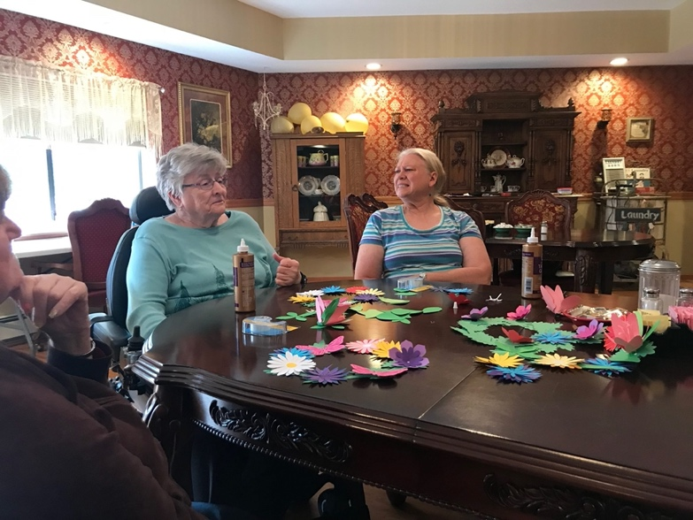
Nine members of Our Savior’s Moravian Church in Altura, Minn., visited three different senior living facilities on their Day of Service. They spent time with the residents, sharing hymns and conversation and making decorative wreaths for their doors. Members of New Philadelphia in Winston-Salem visited the Cherry Street prison to participate and sing in their evening worship service.
At Margate Moravian Fellowship, members collected supplies for the people in the Bahamas devastated by Hurricane Dorian, then packed and delivered them to a central distribution point following their Sunday service.
Faith Moravian Church in Washington, D.C. collected school supplies and backpacks for a local school, as did members at Unionville Moravian in Michigan.
Several congregations took to their neighborhoods to help repair and clean. In Ohio, one group of Schoenbrunn Moravian Church members went to Schoenbrunn Village for a cleanup, while another group did lawn work and power washing for a local child advocacy agency. Members from Sharon Moravian from “ages 4-76” went to help clean the exterior an elderly woman’s home. In Wisconsin, members at Christian Faith Moravian worked to clean and repair a local woman’s home, while those at Glenwood Moravian helped at a local school. Sister Bay Moravian members planted trees and helped a neighbor with housework, and members of the Mountain Laurel Fellowship in Laurel Springs, N.C. built a bridge at a camp for terminally ill children and their families.
In addition to all of this great work, many congregations prepared meals and emergency food kits for local schools and homeless shelters, collected supplies for food pantries and clothing drives, wrote cards and other encouragements for those in care facilities or working for community agencies and created Blessing Bags for the homeless. Others offered a prayer option for those who were unable to participate in one of the work events, but who wanted to pray for their communities and the world.
In many of the Facebook posts, Instagram stories and reports sent in about Moravian Day of Service, Moravians expressed a renewed interest in local mission and finding ways to continue to spirit of the day. At Lancaster Moravian, for example, members signed up for additional volunteer opportunities with Meals on Wheels, the local school district and the community breakfast program. As mentioned earlier, the folks at Christ Moravian in Calgary are looking to continue to offer their aging outreach program.
Thanks to all of the Moravian congregations who contributed stories and photos for this summary and shared their efforts on social media. If you would like to share more about what your congregation did during the Moravian Day of Service, please send stories and photos to Chris Giesler, Board of World Mission, at chris@moravianmission.org.

